

Challenge Yourself, Invent the Future

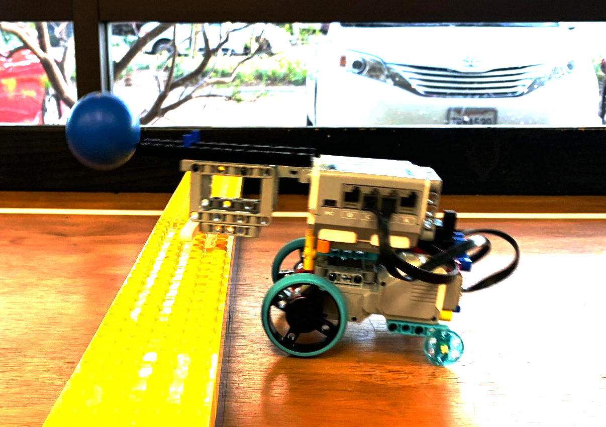

9-16yrs
BALL BLITZ
RULES

1. Team Requirements
- Each team consists of the following:
  - One (1) to two (2) children (team members)
  - One (1) adult coach
  - One (1) robot
- Team members must be between the ages of nine (9) and sixteen (16) on the day of the competition
  - If the date of the competition is moved, the original date will be used as a marker for the competition age cut-off
  - If a student is younger than the required age, permission from the host of the tournament (USEF) must be obtained before participating in the competition, provided that at least one (1) player on the team is of the required age
    - If special permission is given, the age of the oldest student on that team will be used to determine the age group they will compete in
- Team members are only allowed to compete in one (1) team at the event
  - If any team members worked with multiple teams before competition day, they must pick which team they will compete with on competition day
- Coaches may work with multiple teams; however, it is recommended they have an assistant coach for each team
- Divisions: There are two divisions depending on the system you use to build
  - Division 1: EV3 and NXT
  - Division 2: Spike Prime and Robot Inventor

2. Equipment and Materials
- Each team’s robots must be constructed by that team’s members. Construction of any portions of a team’s robot by coaches, teachers, parents, etc. is prohibited
- A maximum of the following electronic LEGO parts may be used:
  - One (1) EV3 (95646c01), NXT (53788), SPIKE (45601), Robot Inventor (88016)
  - Two (2) large motors (EV3: 95658 | NXT: 53787 | SPIKE: 45602)
  - Two (2) medium motors (EV3: 99455 | SPIKE: 45603)
  - Two (2) color sensors (EV3: 95650 | NXT: 55969 | SPIKE: 45605)
  - Two (2) ultrasonic sensors (EV3: 95652 | NXT: 53792 | SPIKE: 45604)
  - Two (2) gyroscopic sensors (EV3: 99380)
  - Two (2) touch sensors (EV3: 95648 | NXT: 53793 | SPIKE: 45606)
- Only LEGO MINDSTORMS EV3 (#31313), LEGO MINDSTORMS NXT (#8547) and LEGO LEGO SPIKE Prime (#45678) and LEGO Robot Inventor (51515) control systems may be used to control the robot
  - Teams can use any software or programming language. Robots must be autonomous during the match. No remote controllers of any type are allowed.
- Any amount of non-electronic LEGO parts may be used to construct the robot
- Materials may not be modified from their original shape
  - Any LEGO parts that appear modified will be checked at the head referees discretion; this check can be performed at any point of the event
  - No parts may be permanently fixed with glue, screws, etc.
3. Robot Specifications
- Maximum weight: 1kg
- Maximum dimensions: Robot must fit into a 25cm cube
- Robots can be constructed in any way as long as they adhere to the Equipment and Materials section
4. Field
- The play field has an inside perimeter of 45 in x 95 in
- The perimeter of the play field has a wall measuring three (3) inches tall
- The mat is secured to a smooth surface in order to ensure that the surface is seamless
  - When securing the mat to the table, use gaffer tape, secured at all four corners, and the midpoints of all four sides.
- Play field details:
  - A divider in the middle separates sides A and B. The divider is made by building a 3 high, 4 stud wide DUPLO wall that spans the width of the table. The wall should be secured to the mat so it does not move when bumped
  - The white area at either end of the field is called Home
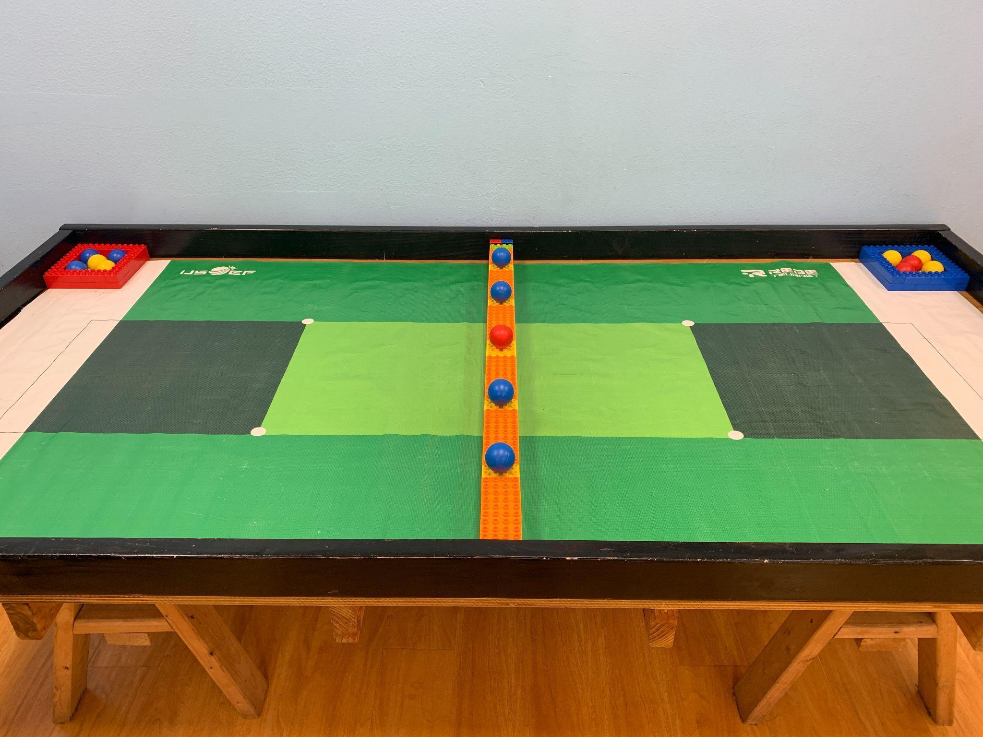

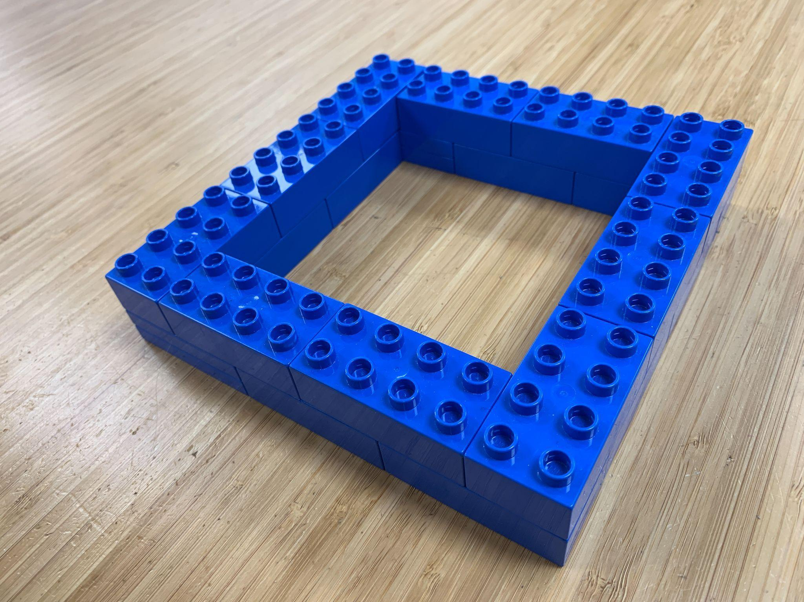
Field cont.
Fifteen (15) LEGO Duplo Ball (41250) will be used as scoring elements

Storage Boxes
There are 2 storage boxes, one red and one blue. They are placed at either side of the field

Items Needed:
20 Red 20 Blue (40) 3011

Field Divider
A divider is placed separating either side of the field. One side is blue and the other side is red. The field is 3 Duplo blocks high and and 4 studs wide. The top row is made up of orange and yellow blocks. The yellow blocks have 5 orange blocks in between them. The center yellow position has two yellow blocks. One edge uses lime green 2x2 brick with Pin on side with grove (22881). This allows for an extra brick to be placed on its side to fill the side gap. If the green block (22881) cannot be used, secure the additional vertical blocks to the wall using an adhesive. Secure the whole field divider to the center of the field using an adhesive such as gaffer tape.

Items Needed:
35 Blue, 35 Red, 28 Orange, 6 Yellow (94) 3011
2 Blue, 2 Red (4) 3437
2 green (2) 22881 (or an additional orange 2x4)
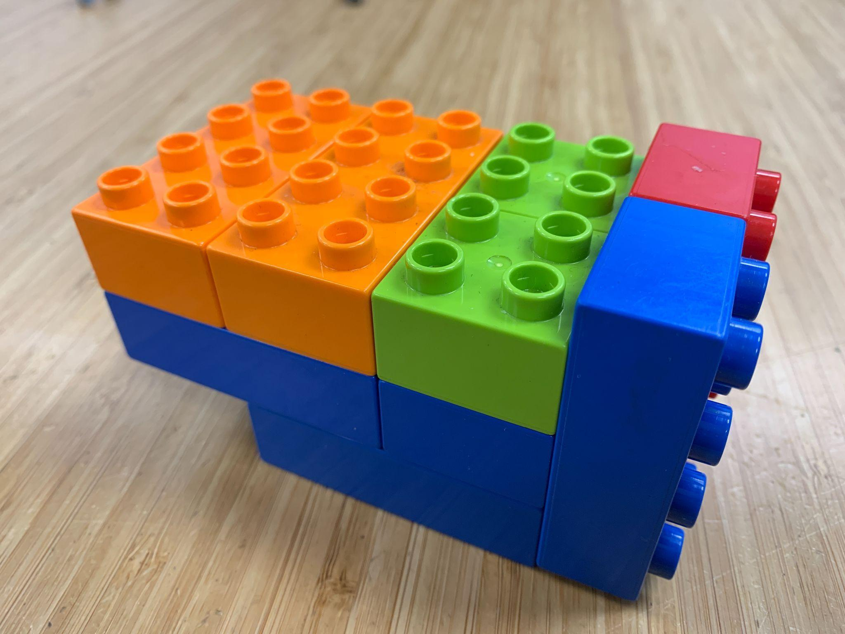
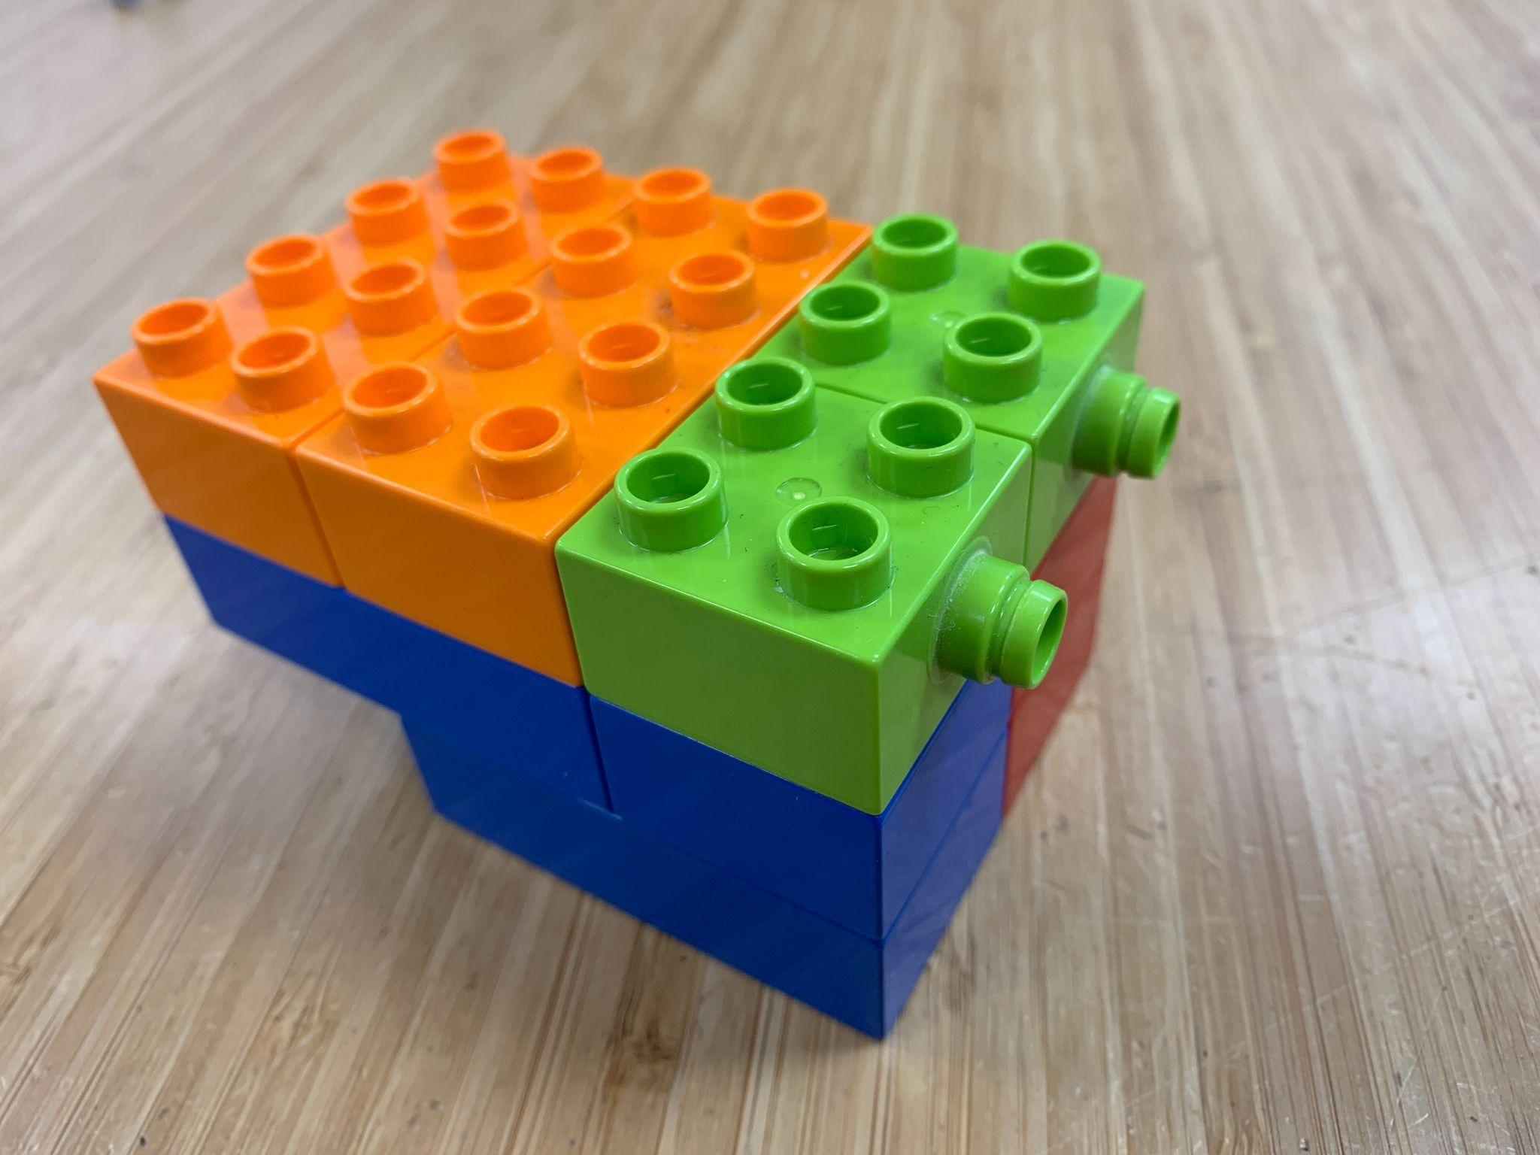

5. Preparing to Play
- Teams play in a 1 vs 1 or 2 vs 2 game of Ball Blitz
- Teams are randomly paired before the beginning of each match
- Preparing the field
  - A center divider is taped down to the center of the field
  - Two (2) storage boxes are used in a game, one (1) for the blue side and one (1) for the red side.
  - Ten (10) balls are placed in the storage areas. Five (5) in each storage area.
  - Five (5) balls are placed along the center divider on the yellow blocks in the center of the blocks.
6. Playing the Game
- Start of the match
  - Robots are placed completely in home, at any position
  - Robots may use one (1) of their Home Zone balls to preload onto their robot
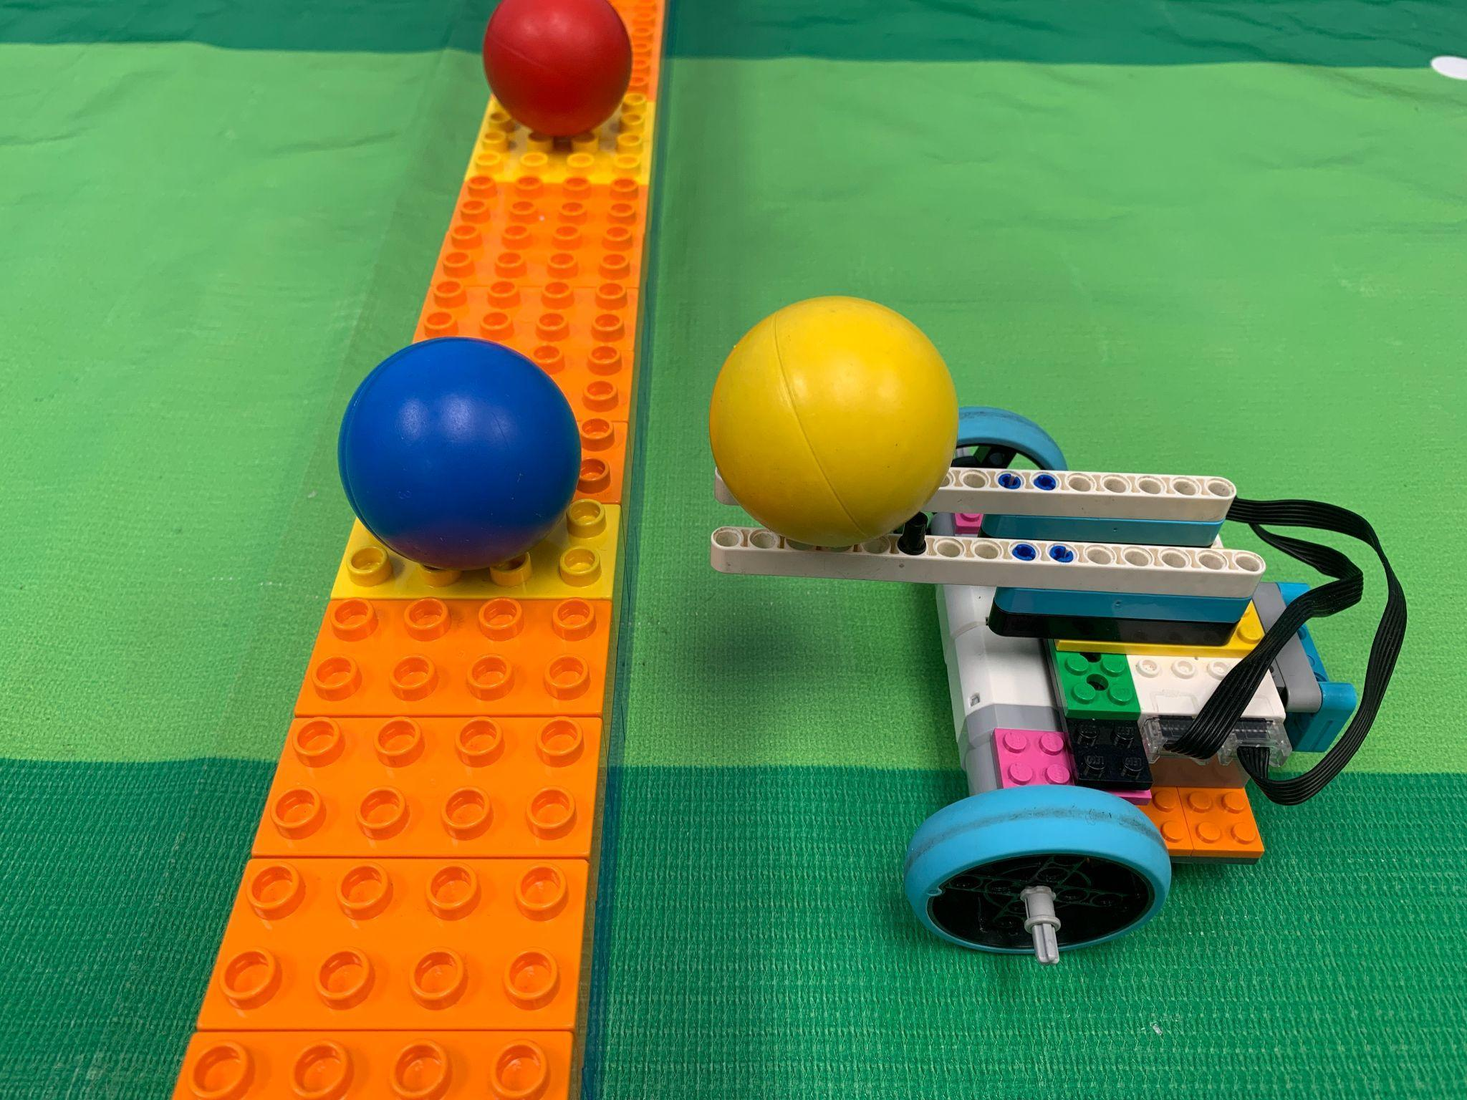
  - The referee will start the match.
- During Play
  - The goal of the game is to push balls over to the other side of the center divider and have the FEWEST amount of balls when the match is over. Each match lasts a maximum of 2 minutes and 30 seconds.
  - Robots can only be touched if any part of the robot is touching the Home Zone.
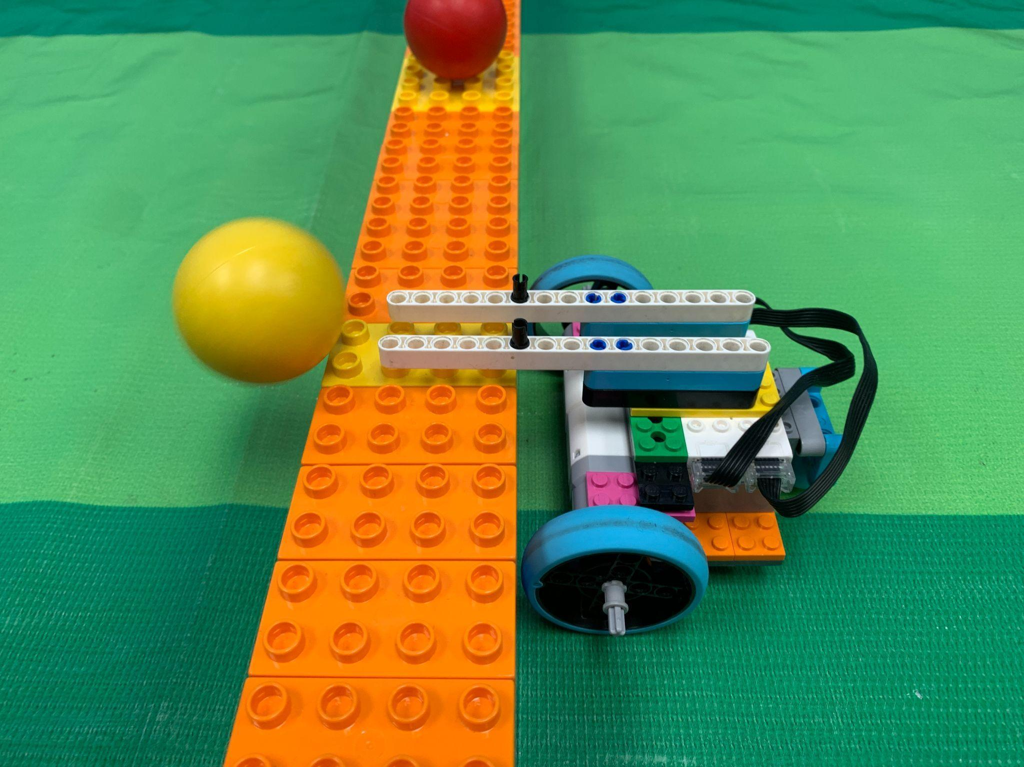
  - If a robot is in home, the human player can load a ball that is in their home onto their robot
  - A robot can only control one (1) ball at a time
  - A robot can push a bonus ball over to the opponent's side, even if they are carrying a ball
  - A robot can move a ball on their side to bring it back to their Home Zone
  - Balls may not be launched from their Home Zone and score on the other side
  - If a ball goes out of bounds, it will be returned to the storage box of the robot who touched it last

- Resolving a Tie
  - If a tie occurs a head to head match is initiated.
  - Robots are placed in their home
  - Only one ball is used and placed in the center position on the center divider
  - When the ref completes saying “READY, GO!” both robots quickly attempt to push the ball to the other side
  - If the ball touches the floor of the other side, the robots with the least amount of balls is the winner
- Penalties
  - If a penalty is given to a team their robot is returned back to their Home Zone
  - Minor Penalties: The robot is returned to home and then a 5 second countdown is started. While the countdown is on, the robot may not move.
    - The robot is touched by the human player if it is completely outside of the Home Zone
    - The human player touches a ball outside of the Home Zone
  - Major Penalties:The robot is returned to home and then a 10 second countdown is started. While the countdown is on, the robot may not move.
    - The robot touches the other side of the center divider
    - The robot scores multiple balls at the same time
    - The robot launches a ball from their Home Zone
  - Disqualification
    - If a team acquires more than one (1) major penalties they are disqualified from the match

