***Challenge Yourself, Invent the Future***

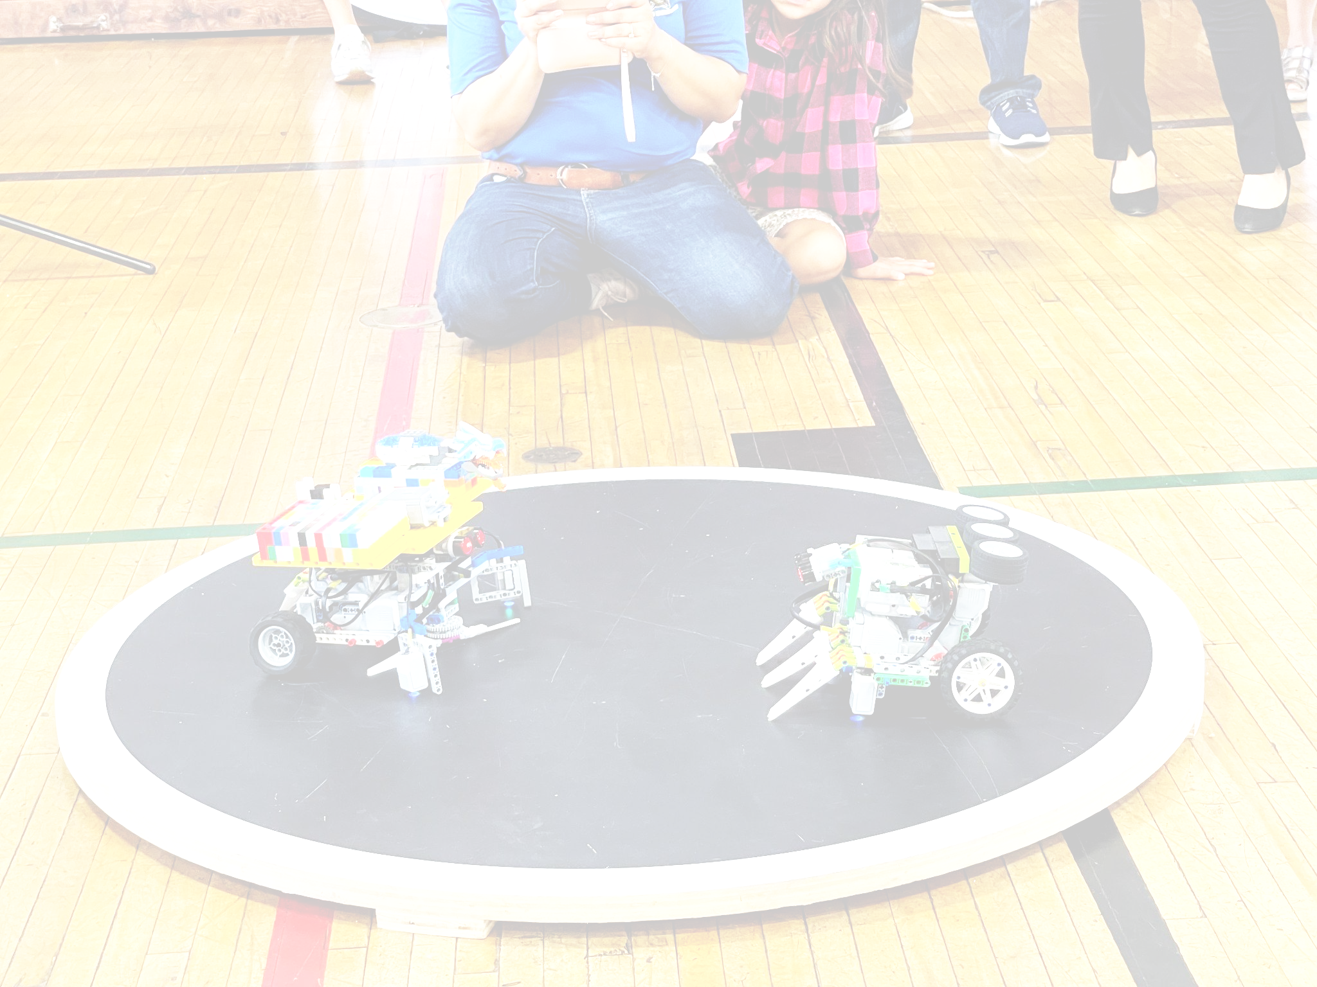

**yrs9-16yrs**

SUMO BOTS

RULES

1. Team Requirements

1. Each team consists of the following:
   1. One (1) to two (2) children (team members)
   2. One (1) adult coach
   3. One (1) robot
2. Team members must be between the ages of **nine (9) and sixteen (16)** on the day of the competition
   1. If the date of the competition is moved, the original date will be used as a marker for the competition age cut-off
   2. If a student is younger than the required age, permission from the host of the tournament (USEF) must be obtained before participating in the competition, provided that at least one (1) player on the team is of the required age
      1. If special permission is given, the age of the **oldest student** on that team will be used to determine the age group they will compete in
3. Team members are only allowed to compete in **one (1) team at the event**
   1. If any team members worked with multiple teams before competition day, they must pick which team they will compete with on competition day
4. Coaches may work with multiple teams; however, it is recommended they have an assistant coach for each team
5. Divisions: There are two divisions depending on the system you use to build
   1. **Division 1: EV3 and NXT**
   2. **Division 2: Spike Prime and Robot Inventor**

2. Equipment and Materials

1. **Each team’s robots must be constructed by that team’s members**. Construction of any portions of a team’s robot by coaches, teachers, parents, etc. is prohibited
2. A **maximum** of the following electronic LEGO parts may be used:
   1. One (1) EV3 (95646c01), NXT (53788), SPIKE (45601), Robot Inventor (88016)
   2. Two (2) large motors (EV3: 95658 | NXT: 53787 | SPIKE: 45602)
   3. Two (2) medium motors (EV3: 99455 | SPIKE: 45603)
   4. Two (2) color sensors (EV3: 95650 | NXT: 55969 | SPIKE: 45605)
   5. Two (2) ultrasonic sensors (EV3: 95652 | NXT: 53792 | SPIKE: 45604)
   6. Two (2) gyroscopic sensors (EV3: 99380)
   7. Two (2) touch sensors (EV3: 95648 | NXT: 53793 | SPIKE: 45606)
3. Only **LEGO MINDSTORMS EV3** (#31313), **LEGO MINDSTORMS NXT** (#8547) and LEGO **LEGO** **SPIKE Prime** (#45678) and **LEGO** **Robot Inventor** (51515) control systems may be used to control the robot
   1. Teams can use any software or programming language. Robots must be autonomous during the match. **No remote controllers of any type are allowed.**
4. Any amount of **non-electronic** LEGO parts may be used to construct the robot
5. Materials may **not be modified from their original shape**
   1. Any LEGO parts that appear modified will be checked at the head referees discretion; this check can be performed at any point of the event
   2. No parts may be permanently fixed with glue, screws, etc.

3. Robot Specifications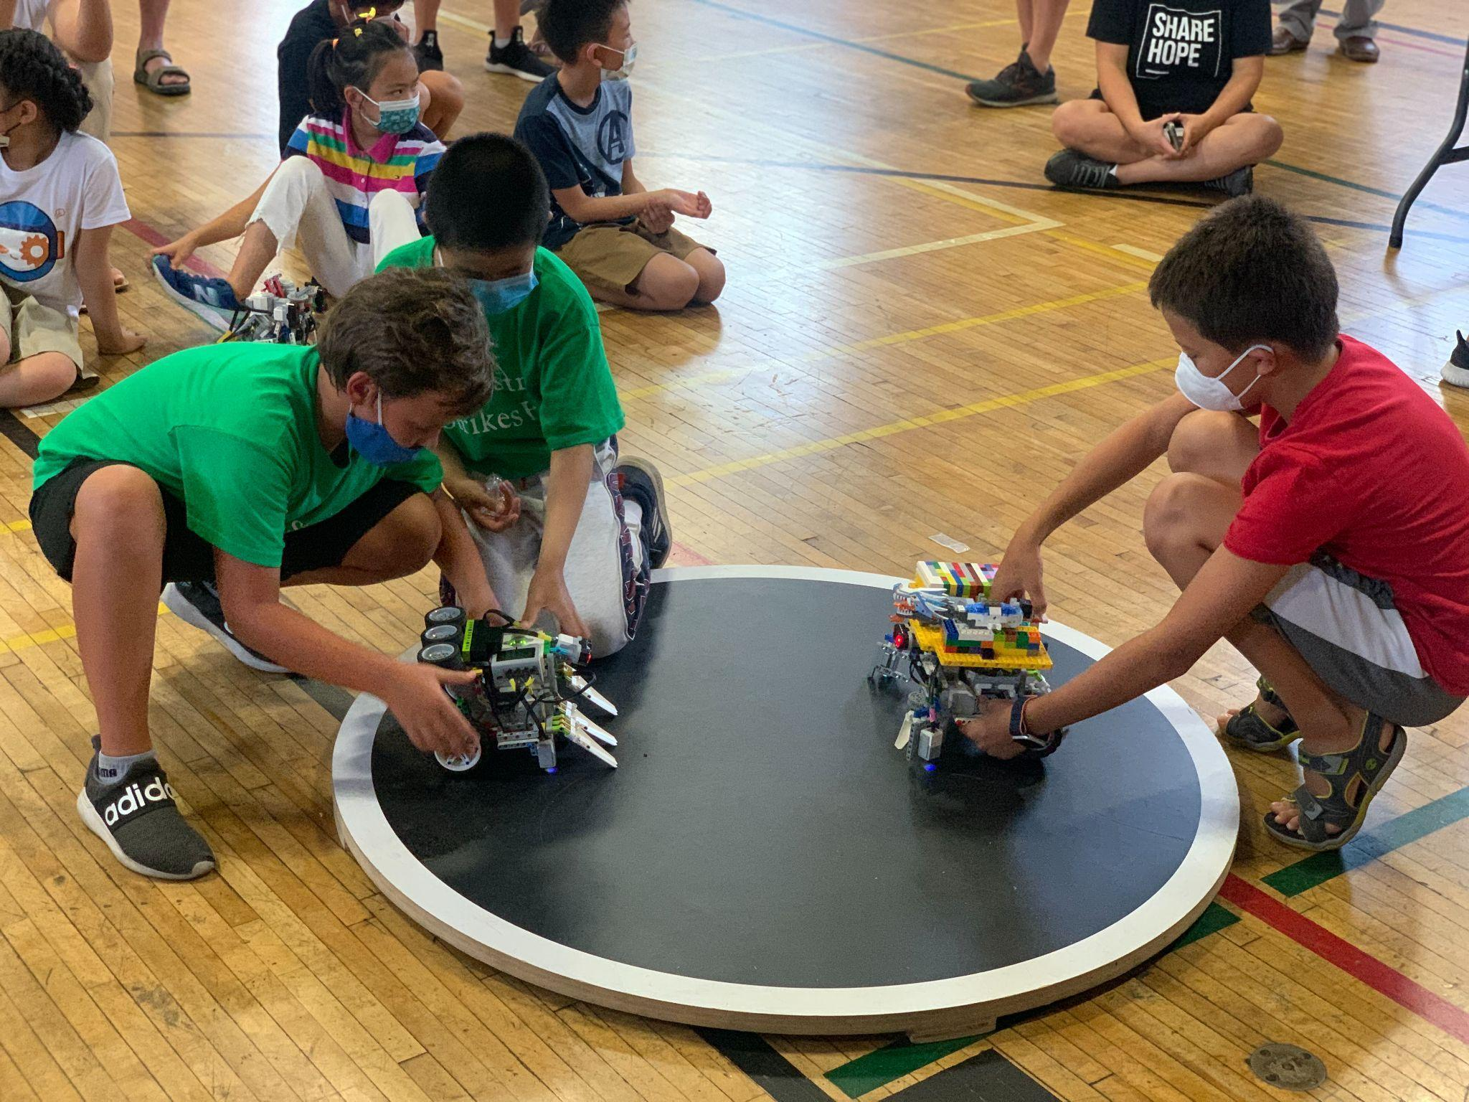

1. Robots must be built using only **LEGO pieces**
2. Each robot’s weight and dimensions will be inspected at check in at the beginning of the event
   1. Maximum weight: **1kg (1000 grams)**
   2. Maximum dimensions: the robot must fit within a **25cm cube** (the sizing tool may have a tolerance of +-1 cm).
      1. Robots may expand once the match starts
      2. When being sized, robots may touch any part of the box and should return to its original shape once removed
3. **No official LEGO metal parts** may be used on the robot except for the steel ball bearing. The steel ball bearing may not be used on any form of active weapon that is powered by a motor
4. Additional unpowered electronics may **not be used** if the maximum has already been used on the robot. LEGO Power Functions Battery 8881 is prohibited even if it is just used for weight. Please refer to 2.B for a full list of electronics that may be used.

4. Field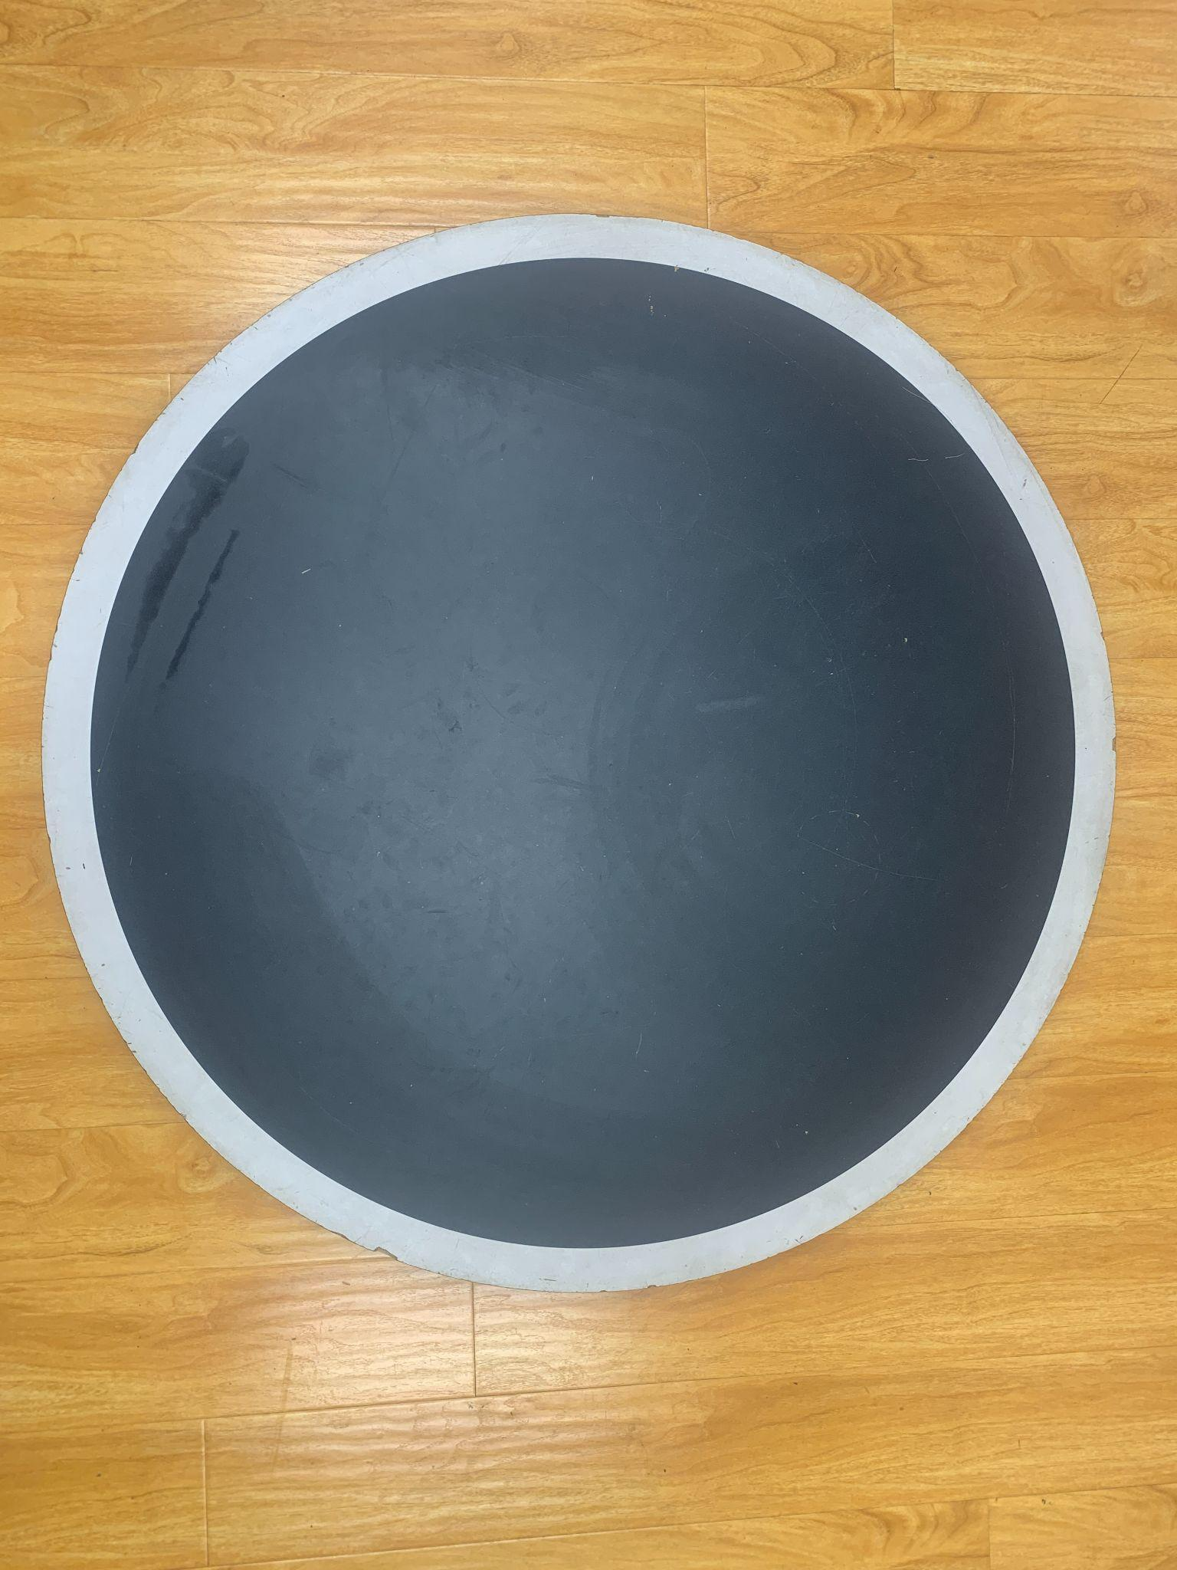

1. The play field is a **round Sumo Table**
2. Dimensions of the table:
   1. Four (4) ft diameter, black, circle
   2. Two (2) in, white outline along the edge of the table
   3. The top of the table is two (2) to four (4) inches above the ground
3. Dividing Barrier
   1. **A barrier that is approximately 4 ft long and 3 ft tall** marks off each side of the play field. It must be opaque and block any view of the other side of the field.
   2. The barrier is removed once the match begins, before the robots move, to reveal the placement of the robot by the opponent.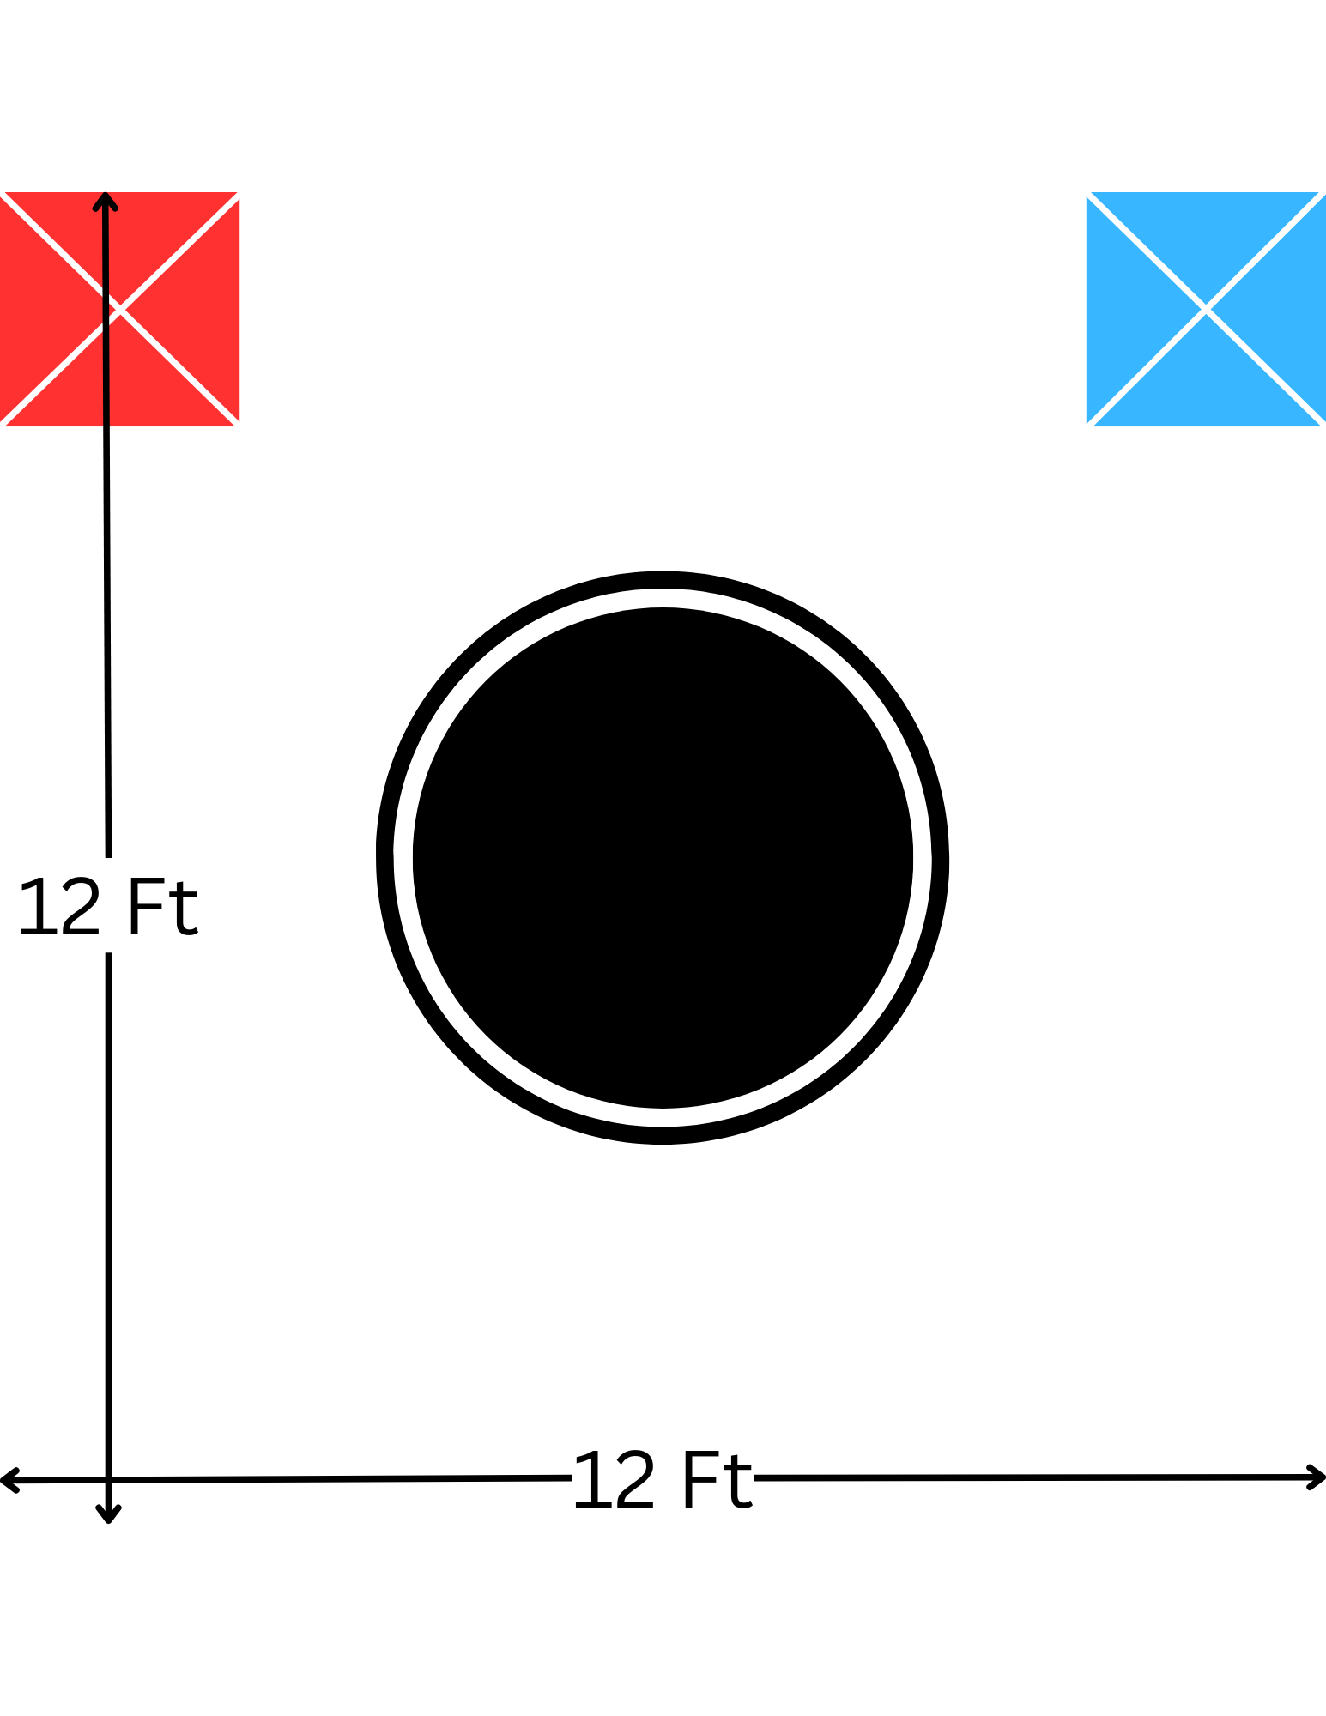
4. Play Area
   1. An **area of 12ft x 12f**t must be set up with the Sumo Table in the middle of the space.
   2. Standing locations dictated by X marks taped at the corners of the play area
   3. Only the referee(s) may move around the play area during a match

5. Playing the Game

1. Matches are played with two (2) Sumo robots; one robot opposing the other.
2. Matches last a maximum of one (1) minute
3. Starting a Match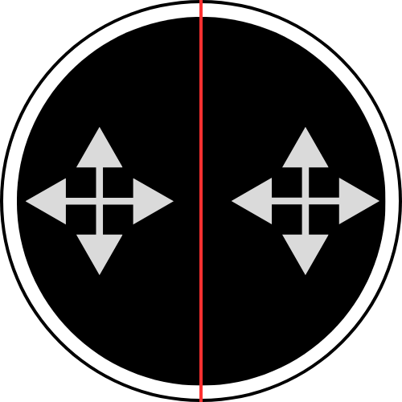
   1. Robots are placed on the table facing **any direction** on their half of the field designated by the barrier
      1. Once a robot has been placed on the field it cannot be adjusted again. If adjusted after placement, robots will be disqualified from the match. Minor movement may occur when pressing the start button.
      2. All team members must be on their half of the field when placing the robot down
      3. No outside communication between team members and coaches, parents, spectators, etc may occur when placing the robot down.
   2. The referee will start the match via countdown
   3. Once the countdown is complete, team members will launch their code and move away from the table
      1. **Robots must have a five (5) second “wait”** where the robot does not move, at the beginning of their code to leave time for team members to step away from the table
   4. Once the match has started, the referee will **remove the barrier before the robots begin to move**
   5. After starting the match, contestants **must stand at the designated standing location**. They cannot leave the location until the referee has called the end of the match.
4. Ending a Match
   1. Robots will attempt to “knock out” the opposing robot; this consists of:
      1. **Pushing a robot out of the field** until any part of the robot touches the floor.
      2. **Flipping a robot** so it is no longer able to move forward or backward on its own.
   2. The match ends when any robot is knocked out
   3. If robots are not able to knock the opponent out before the time limit has been reached a tie will be called.
   4. If very little or **no driving movement** is detected by both robots during the match, the referee may begin a five (5) count that signals the match is ending early and will result in a tie.
5. Resolving a Tie
   1. Robots will run an additional match with the robot positioned as per rule 5.C.a
6. Tournament Set-up
   1. Tournaments conducted in any combination of
      1. Round Robin only
      2. Round Robin and Bonus Game in any order
      3. Round Robin and then Eliminations
      4. Round Robin, Bonus Game, and then Elimination

6. Bonus Game Types

1. Additional games may be played at events and may or may not count towards over rankings at the event at the discretion of the event organizer.
   1. **Free for All (FFA)**
      1. **3, 4, 5, or 6** robots may be placed on the table with any part of the robot **touching the white border line**. Robots should be placed equidistant from each other. After placement has occurred the referee may edit the position of the robots before the start of the match to ensure a fair match.
      2. **No barrier is used.**
   2. **2 vs 2**
      1. Robots are paired up with a partner and complete a regular match. If a robot is pushed out of the arena, they are knocked out. **The team with the last robot on the field is declared the winner.** Robots are not allowed to be touched or turned off even if they are knocked out of the arena until the match winner has been declared to ensure no human interference on the match results.
      2. **Barrier is used**

7. Additional Rules

1. When starting a match, participants must be present at the match. If a contestant is not at the match, they will be called 3 times by the referee. If the contestant does not appear at the table when called, they may be disqualified from the match.
2. If a robot breaks during a match, the match continues until one of the Ending a Match (5.D) criteria are resolved.
   1. If a robot breaks during an elimination stage and they have another match in the set, they are given about 1 min to complete repairs. It is up the referee to decide how much time is allotted.
3. If a robot breaks when being placed on the table, the referee may, but not be required to, give time for repairs.
4. Robots may be resized using the original sizing tool used at check in during inspection at the head referees discretion.
   1. If a robot fails inspection they will have time to return the robot back to size before their next match
   2. If a robot fails inspection, no penalties will be awarded to the robot the first time. If the robot failed inspection for a second time, the robot will be disqualified from the tournament if proven egregious.
   3. A robot can only be called for inspection before a match begins. Results cannot be changed once the match has been completed
5. Once the results of a match have been submitted, they cannot be changed. It is the contestants responsibility to double check match results with the referee before they submit it to the admin table. Once the scores have been submitted they will not be changed unless due to a clerical error during submission.
6. If there are an abundance of teams registered for an event, the event organizer may split up the group into different age groups. Examples of age groups could be 9-11 and 12-16.