

***Challenge Yourself, Invent the Future***

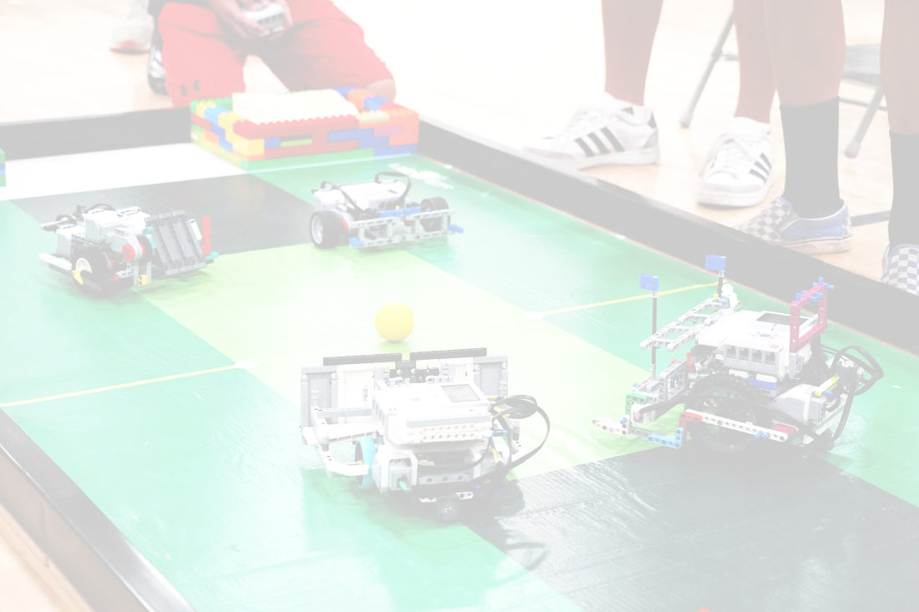

**9-16yrs**

SOCCERBOT

RULES

## 1. Overview

1. Each team consists of 1-3 children and 1 adult coach.
2. There are two divisions that are separated by age. (May vary on orgonizers’s discretion)
   1. Jr Division: 9-12 years old
   2. Sr Division: 13-16 years old
3. Team members must be no older than 12 or 16 for their respective division on the day of the competition. If the competition day is moved, the original date will be used as a marker for the competition
4. If a player is younger than the required age, permission from the host of the International Tournament must be obtained before participating in the competition, provided that at least one player on the team is of the required age.
   1. If special permission is given, the oldest student will be used to determine the division they will participate in.
5. Team members are only allowed to compete in **one (1) team at the event.** If they worked with multiple teams throughout the competition, they must pick which team they will compete with on the day of the competition.
6. Coaches may work with multiple teams. It is recommended that if a coach has multiple teams, they have assistance for each team such as an assistant coach.

## 2. Equipment and Materials

1. **Each team’s robots must be constructed by that team’s members**. Construction of any portions of a team’s robot by coaches, teachers, parents, etc. is prohibited.
2. A **maximum** of the following electronic LEGO parts may be used:
   1. One (1) EV3 (95646c01), NXT (53788), SPIKE (45601), Robot Inventor (88016)
   2. Two (2) large motors (EV3: 95658 | NXT: 53787 | SPIKE: 45602)
   3. Two (2) medium motors (EV3: 99455 | SPIKE: 45603)
   4. Two (2) color sensors (EV3: 95650 | NXT: 55969 | SPIKE: 45605)
   5. Two (2) ultrasonic sensors (EV3: 95652 | NXT: 53792 | SPIKE: 45604)
   6. Two (2) gyroscopic sensors (EV3: 99380)
   7. Two (2) touch sensors (EV3: 95648 | NXT: 53793 | SPIKE: 45606)
3. Only **LEGO MINDSTORMS EV3** (#31313), **LEGO MINDSTORMS NXT** (#8547) and LEGO **LEGO** **SPIKE Prime** (#45678) and **LEGO** **Robot Inventor** (51515) control systems may be used to control the robot
   1. Teams can use any software or programming language. Robots can be autonomous during the match or user controlled outline in 2.5 *Equipment & Materials*
4. Materials may **not be modified from their original shape**
   1. Any LEGO parts that appear modified or permanently fixed with glue etc. will be checked at the head referees discretion; this check can be performed at any point of the event.
5. Robots require a way to control them
   1. Control programs are available through LEGO MINDSTORMS series products, cellphones, laptops, tablets, and EV3 controller software.
   2. One (1) additional EV3 brick may be used as a controller, connected through bluetooth only. Additional sensors and motors may be used on the controller that is not counted towards *2.2 Equipment & Materials*

## 3. Robot Specifications

1. Robots must be built solely with LEGO pieces
2. Robots will be measured on weight and dimensions at check in at the beginning of the event
   1. Weight limit: 1kg
   2. Dimension limit: the robot must fit within a 25cm cube.
      1. When determining the dimensions the robot and its extensions must be fully extended when determining size.
3. Limitations on holding the ball are as follows
   1. Half of the ball 25mm (1in) must stick out from the robot
      1. At check-in the judge will use a ball, planted on the table surface, and push the ball around the perimeter of the robot. If the ball goes into the robot more than 25mm (1in) the robot will need to make modifications and check in again before the end of the check in session. If it fails before then end of check-in the robot will not be allowed to compete
      2. See figures below, Green outlined is ok, Red outlined is restricted
   2. When in possession of the ball, the robot cannot enclose the ball within the robot
      1. Possession is defined as the ball is touching the robot
   3. When in possession of the ball, the ball must be rolling while the robot is in motion
   4. An opponent robot must always have a pathway to the ball or a penalty countdown will begin. *See 5F Preparing to Play for explanation on countdowns.*

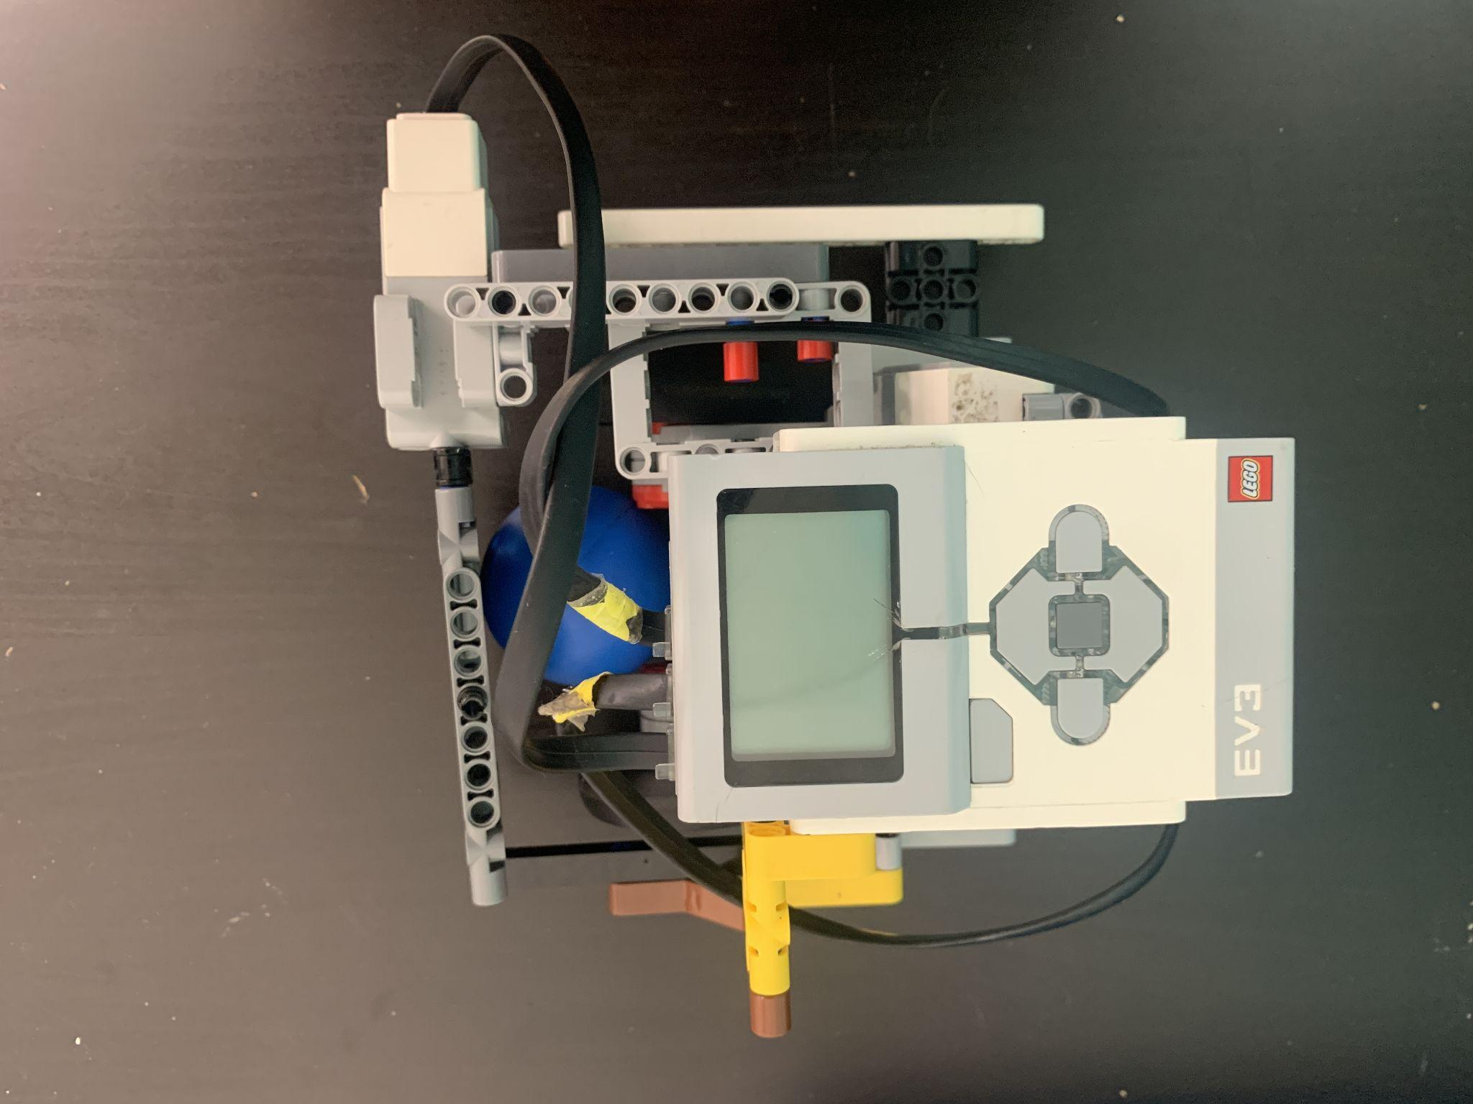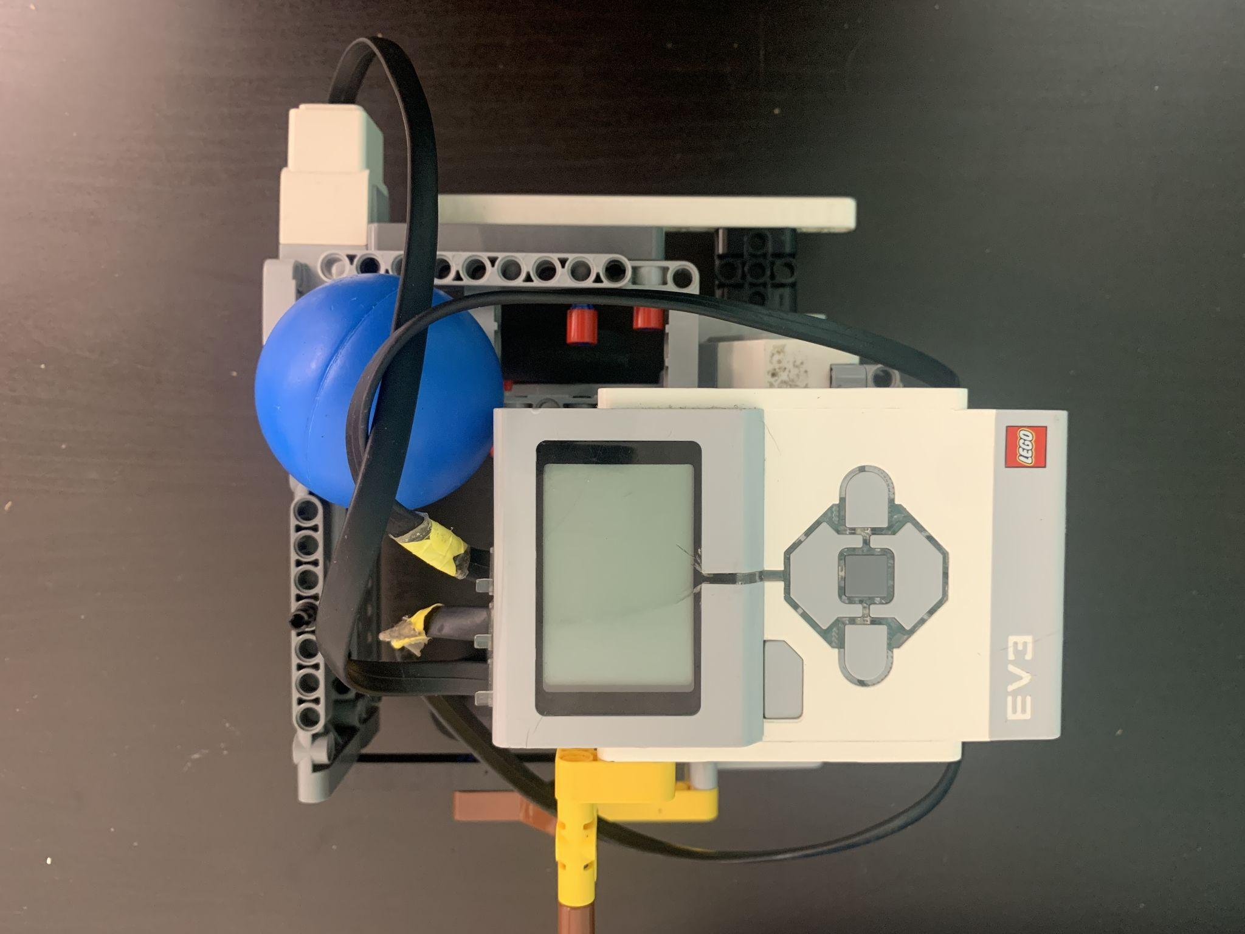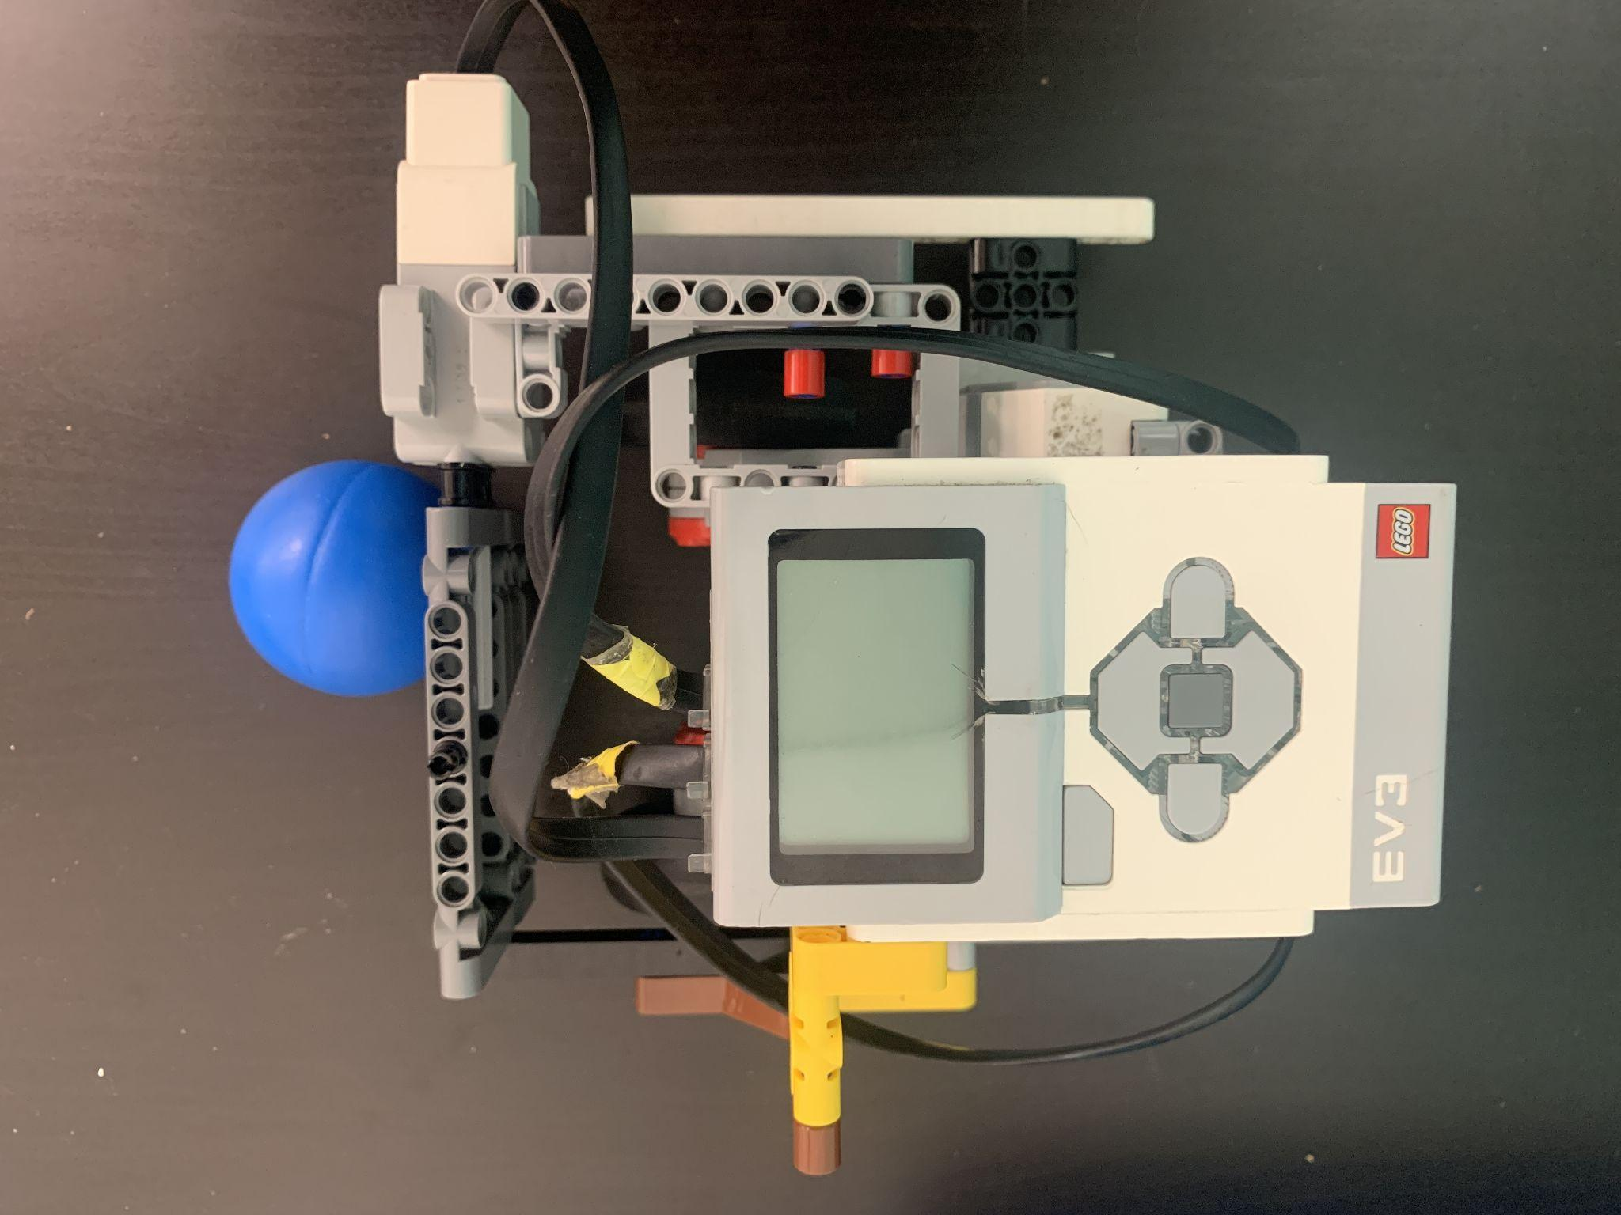

## 4. Field

1. The play field has an inside perimeter of 44in x 92.5in
2. The perimeter of the play field will is 3 in tall
3. The soccer field will be constructed with a smooth surface
4. The provided Robo Tourney EV3 SoccerBots pitch will be placed in the center of the play field
   1. When securing the pitch to the table ensure that there is 10in space from the edge of the pitch to the perimeter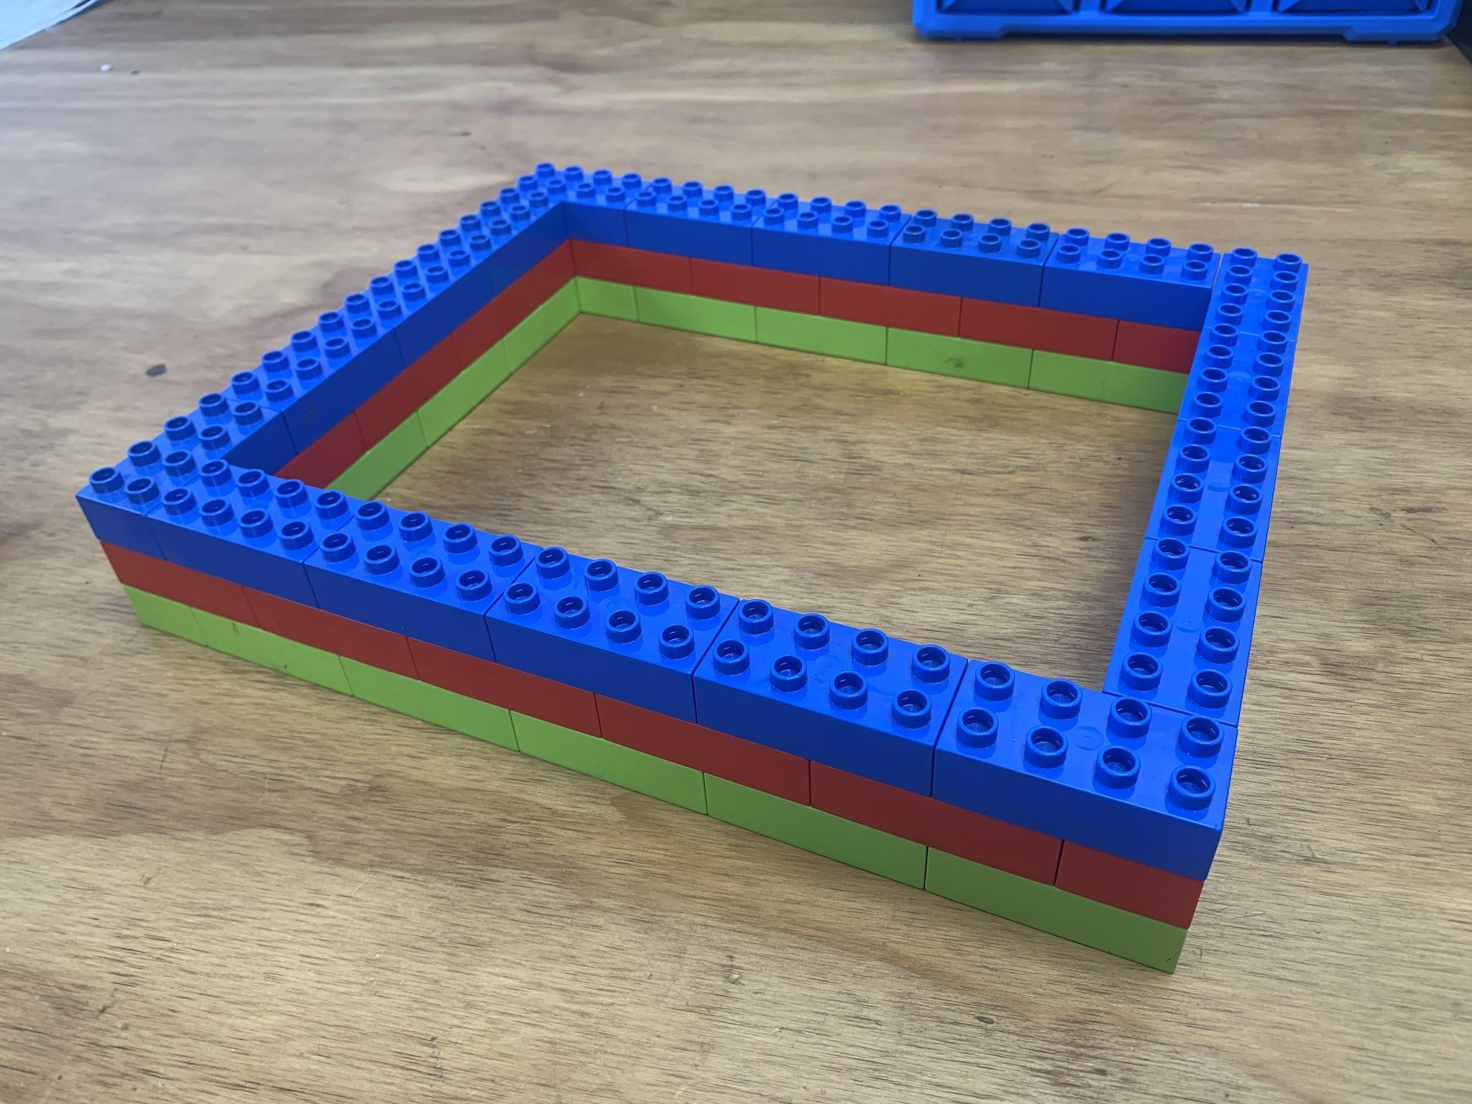
   2. The pitch is fastened to the table with tape over the top edge at the goal ends. No more than 0.4 in of tape may protrude into the play area. Do not place tape in the goal area indicated by the 17.7 in marker on the model.
5. The extra area on either side of the pitch will be outlined with LEGO Duplo to create the goal

## 

## 5. Preparing to Play

1. Games will be played where two teams of two robots play a game of soccer
   1. Two team members from each robot may be present at the competition table. These members will be the driver and the support
2. The objective of the game is to score as many points before the 3 minute timer runs out
3. Robots have two roles to pick from and can only be one role for the entirety of the match
   1. Goalkeeper: The goal keeper's job is to protect their side of the play field and prevent opponents from scoring in their goal.
      1. The goalkeeper is the only robot allowed to stay in their penalty zone.
      2. The goalkeeper may not cross into the other half of the field
   2. Striker: The striker collects the ball and scores it in the opponents goal
      1. The striker is allowed to travel across the whole field but is not allowed to be within either of the penalty zones
4. Driver and support roles
   1. Driver: Controls the robot using their teams device
   2. Support: Will pick up the robot and place it in the designated starting position
   3. If there is only one team member they driver will also have the roll of the support
5. Start of the match
   1. The ball will be placed in the center of the pitch
   2. The robots will be positioned on the corners of their goalie zone
   3. After a countdown from the judge, the robots will move to take control of the ball and score in the opponents goal

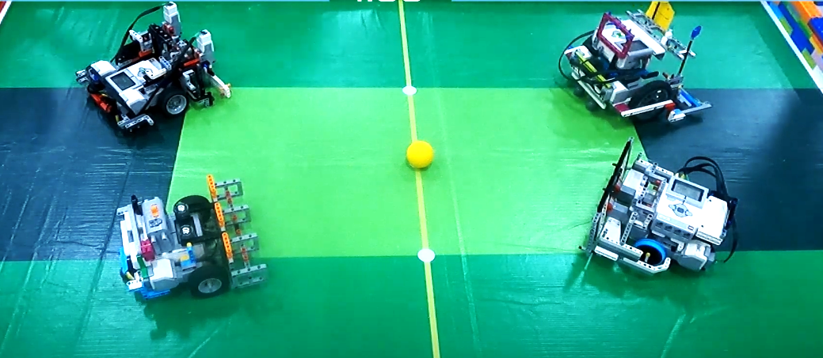

1. During play
   1. A goal is scored when the ball goes completely into the goal
   2. The robots may not pin another robot or impede its movement for more than 5 seconds. This will be enforced by the judge by a countdown from 5 to 1. Before the end of the countdown the robots must be separated.
      1. If a robot does not purposefully separate before the end of the countdown their team will be receive a penalty token
   3. Robots are not allowed to enter the penalty zone on their side but they can enter the penalty zone on the opponent's side
      1. If a robot enters the opponents penalty zone, they must leave within 5sec.
      2. If the robot does not leave the penalty zone before the end of the countdown they will receive a penalty token
2. Penalty Tokens
   1. Robots may receive a penalty token if they
      1. False start when the match starts or resumes play
      2. Excessively damaging another robot, the field, pitch, goals, etc.
      3. Breaks the conduct for the spirit of the game
   2. If a team received three (3) penalty tokens by the end of the match they will be disqualified from the match resulting in a loss and a goal score of 0.
   3. If a robot is disqualified two times throughout the competition they will be disqualified from the rest of the event.

