

***Challenge Yourself, Invent the Future***

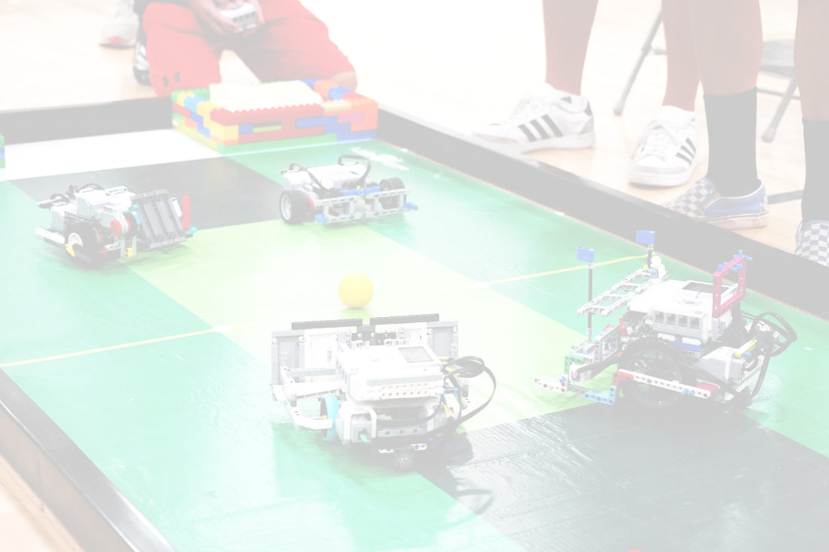

**6-10yrs**

SOCCERBOT

RULES

## 1. Overview

1. Students will be facing off in a two (2) versus two (2) soccer competition using robots completely built and coded by each team
2. Teams consist of one (1) to two (2) students
3. Students must be no younger than six (6) and no older than ten (10) years old on the day of the competition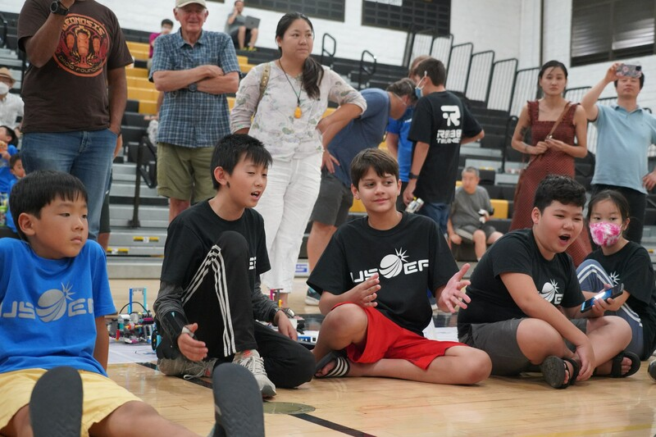
4. There are two separate divisions that will compete independently of each other: a LEGO WeDo 2.0 division and a Spike Essentials division. Robotics systems including motors and sensors must be from each respective set, e.g., if you are using Spike Essentials, you cannot use any WeDo 2.0 motors or sensors
   1. Division 1: WeDo 2.0
   2. Division 2: Spike Essentials
5. Coaches may work with multiple teams; however, it is recommended to have an assistant coach for each team

## 2. Equipment and Materials

1. A maximum of two LEGO WeDo 2.0 (45300) or Spike Essentials (45345-1) system’s may be used
2. A LEGO Duplo Ball (41250) will be used as the “soccer ball”
3. Students may use up to four (4) motors and any amount of sensors
4. Any amount of LEGO pieces may be used to construct the robot
5. LEGO and robotics systems may not be modified from their original shape
   1. Any LEGO that appears modified will be checked at the head referee’s discretion
   2. Robot parts cannot be permanently fixed with glue, screws, etc.
6. Robots will require a way to control them;
   1. Controllers can consist of up to two (2) of the following in any combination:
      1. Laptop
      2. Phone
      3. Tablet
7. Students may only code using Scratch, LEGO WeDo 2.0, or LEGO Spike Essentials
8. Students are not allowed to adjust their code during a match

## 3. Robot Specifications

1. Maximum weight: 1 lb or 0.5 kg
2. Maximum dimensions: Robot must fit into a 25cm cube
   1. Each robot and its extensions must be fully extended when determining size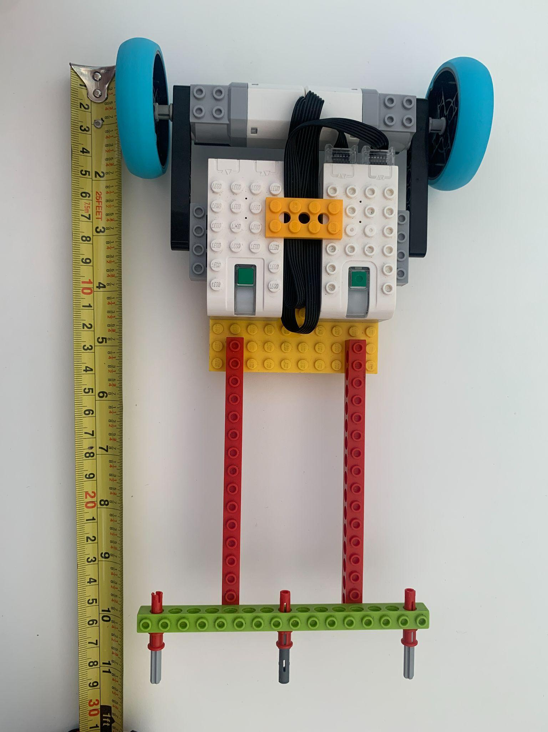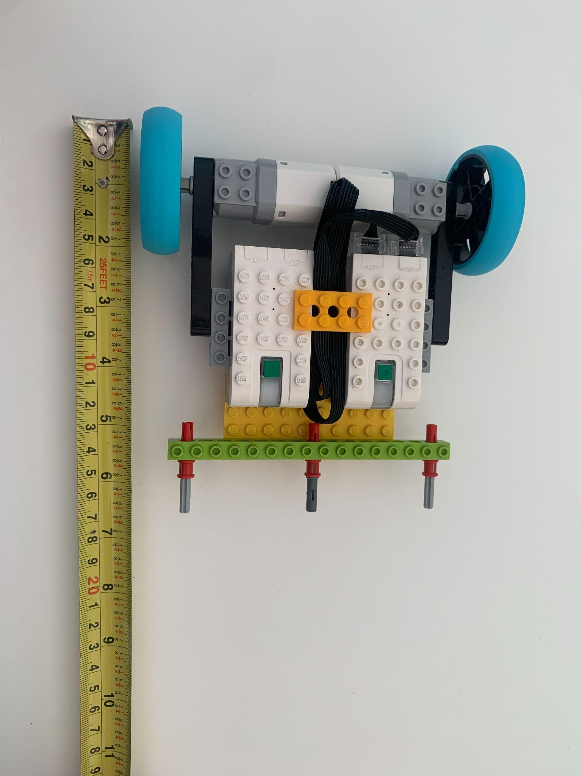



1. Limitations on holding the ball are as follows:
   1. When in possession of the ball, the robot cannot enclose the ball within the robot
      1. Possession is defined as the ball turning when your robot is turned
   2. Half of the LEGO Duplo ball must stick out from the robot
   3. The robot cannot carry the ball on top of it or allow the ball to go under it
   4. When in possession of the ball, the ball must be rolling while the robot is in motion, e.g., teams cannot use an attachment that picks up the ball off of the mat or grip the ball so it stops the ball's motion

Check- In

* 1. At check-in, the head referee will test each robot for ball enclosure; if more than half of the ball fits into the robot, it will need to be modified by the team members before the end of the check-in session. If the robot fails to meet these standards by the end of the check-in session, the robot will be disqualified

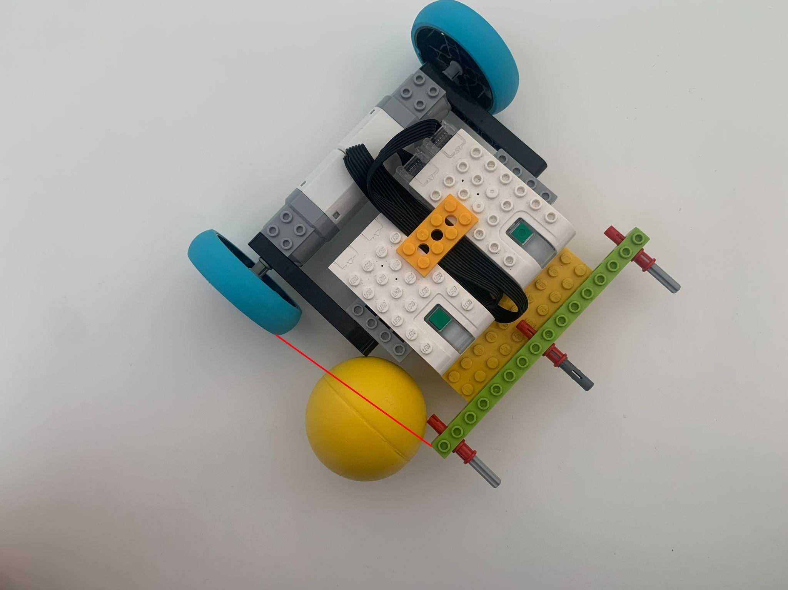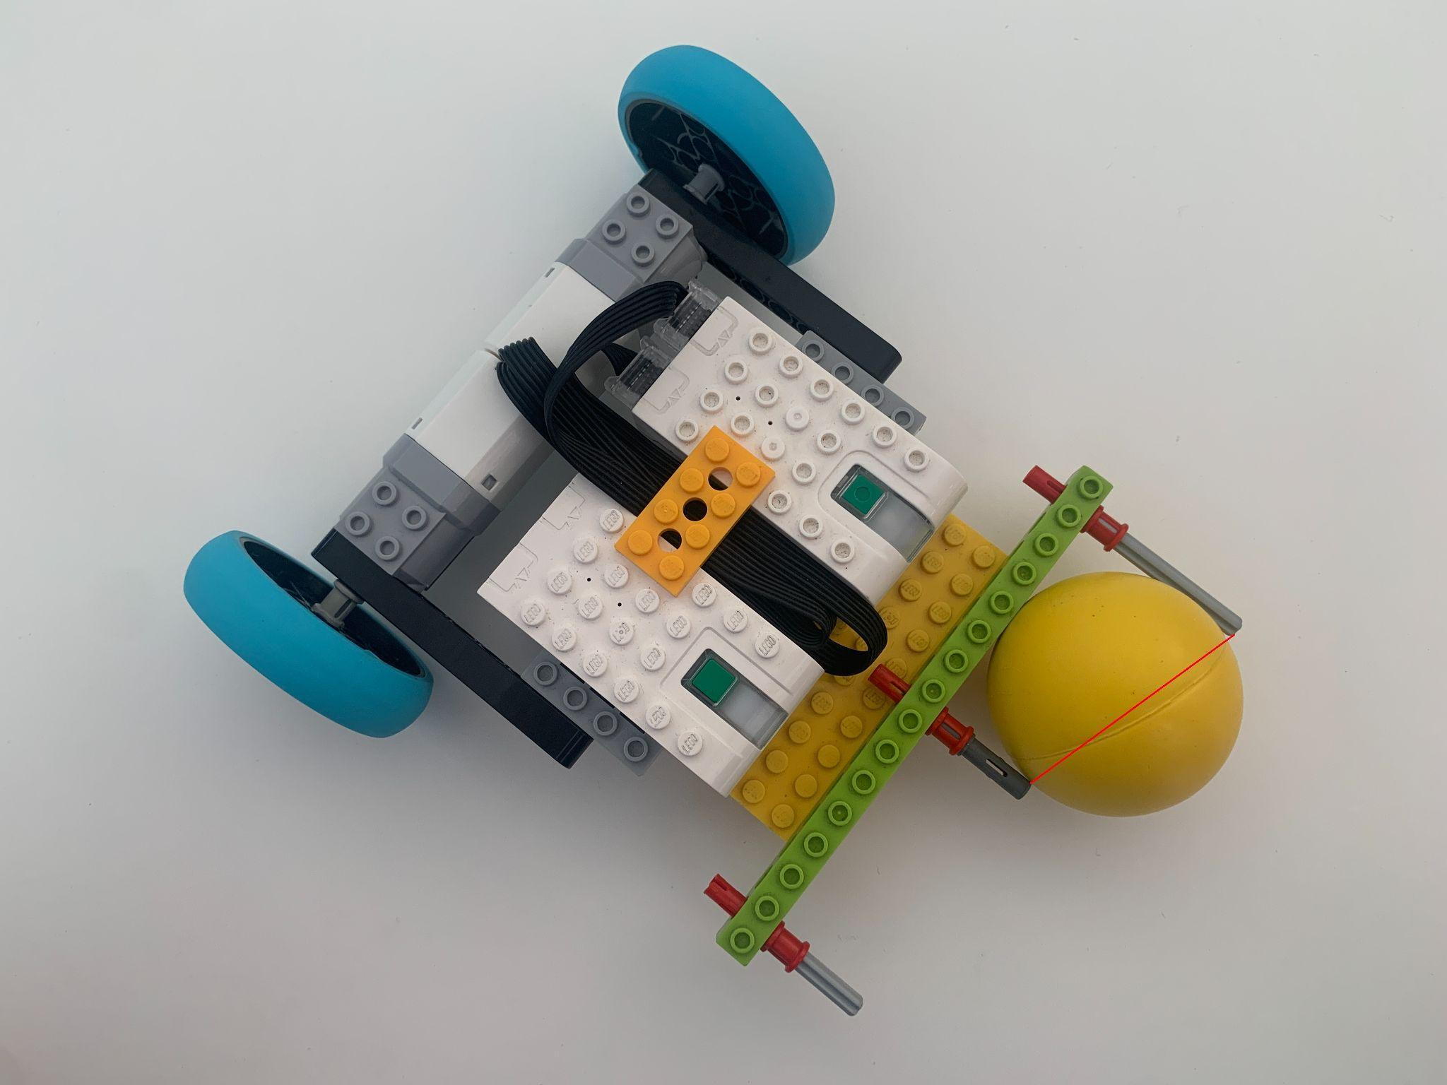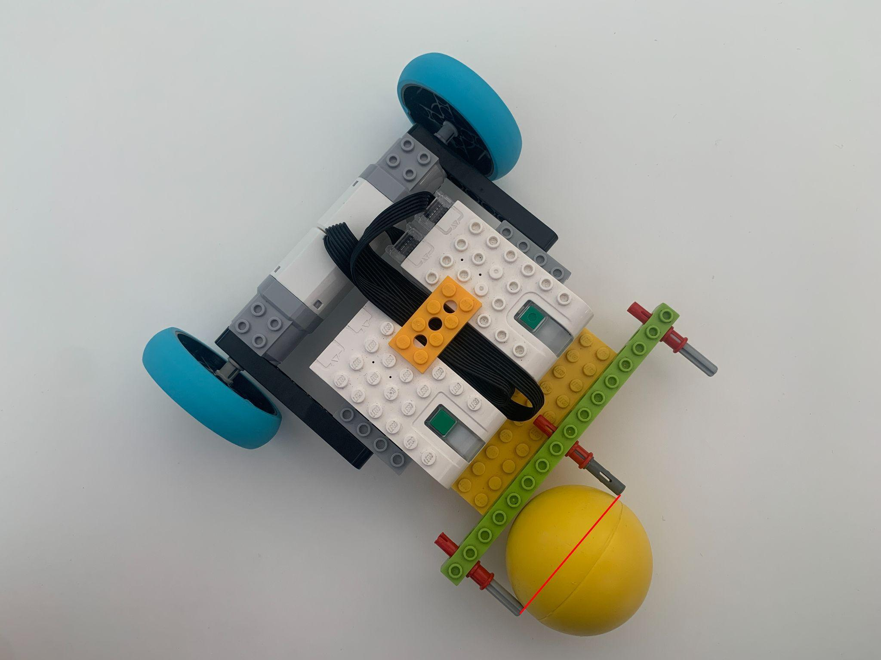

## 4. Field

1. The play field has an inside perimeter of 45 in x 95 in
2. The perimeter of the play field has a wall measuring three (3) inches tall
3. The mat is secured to a smooth surface in order to ensure that the surface is seamless
   1. When securing the mat to the table, use NANO Magic Tape Double Sided at the four (4) corners of the mat. A link to the tape can be found here: <https://www.amazon.com/Transparent-Reusable-Waterproof-Adhesive-Cleanable/dp/B09FTDMVZN>
4. The goal extends across the whole white area of the field.
5. Play field details:
   1. The line in the middle separates sides A and B
   2. The white areas at the ends of the mat are the goals
   3. The dark area in front of the goal is the goalie zone
   4. The white dots at the corner of the goalie zone indicate robot starting positions
   5. The white dot on the middle line indicates the starting ball placement

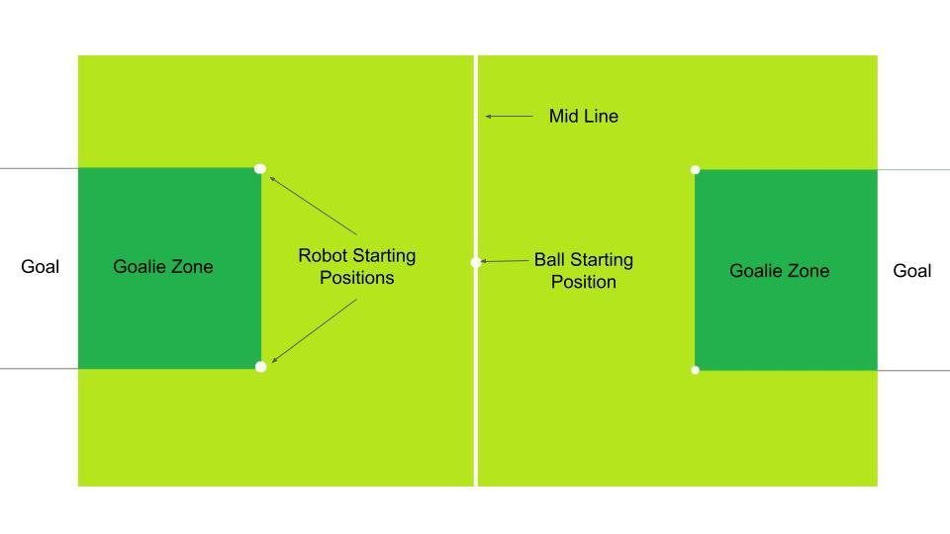

## 

## 5. Preparing to Play

1. Teams play in a 2 vs 2 match of soccer
2. Teams are randomly paired before the beginning of each match
3. The objective of the game is to score as many goals as possible before the 2.5 minute timer runs out
4. Robots have two roles to pick from, and must remain the same role until the end of the match. In between games and rounds, students may switch which role they are in as long as they specify with the referee. The two available roles are:
   1. Goalkeeper:
      1. The goalkeeper's job is to protect their side of the play field and prevent opponents from scoring in their goal
      2. The goalkeeper is the only robot allowed to stay in THEIR team’s goalie zone for an indefinite amount of time
      3. The goalkeeper may not cross into the opponent's half of the field. If this occurs, a penalty token will be awarded to the offending robot
   2. Striker:
      1. The strikers job is to collect the ball and push it into the opponents goal
      2. The striker is allowed to travel across the whole field but is not allowed to be within either team's penalty zones for more than five seconds. If this occurs, a penalty token will be awarded to the offending robot

## 6. Playing the Game

1. Start of the match
   1. The ball will be placed in the center of the mat on the white circle
   2. The robots will be positioned on the corners of their goalie zone
   3. After a countdown of five seconds from the referee, the robots will move to take control of the ball and score in the opponents goal
2. During Play
   1. A goal is scored when the ball goes completely into the goal
   2. The clock never stops. Robots must quickly be placed in their starting locations after a goal has been scored or a penalty has been awarded
   3. The robots may not tackle another robot or impede its movement for more than 5 seconds. This will be enforced by the referee by a countdown from 5 to 1. Before the end of the countdown the robots must fully be separated. If a robot does not purposefully separate before the end of the countdown, their team will receive a penalty token.
   4. Robots designated as “striker” are not allowed to enter either team’s goalie zone for more than five seconds. If this occurs a penalty token will be awarded to the offending robot
   5. Any robot that is at least partially inside the goal will be given 5 seconds to leave before they get a penalty token. If an opposing robot pushes the goalie into their own goal, the countdown for separation will begin and once that countdown has been resolved a new countdown for leaving the goal area will begin.
3. Penalty Tokens
   1. Robots may receive a penalty token if they
      1. Are designated as a “striker” and enter either penalty zone for more than five seconds. A referee will count from five to one in order to ensure that a penalty token is properly given
      2. Are designated as a “goalkeeper” and cross the mat into the opposing team’s side. NOTE: If a goalkeeper crosses the midpoint line of the mat they will NOT be given five seconds to return to their side. Instead, they will be given a warning first at the referee's discretion, and then receive a penalty token
      3. Impede the movement of an opposing robot for more than five seconds.
      4. Impeding the movement of the ball by trapping it under or on top of the robot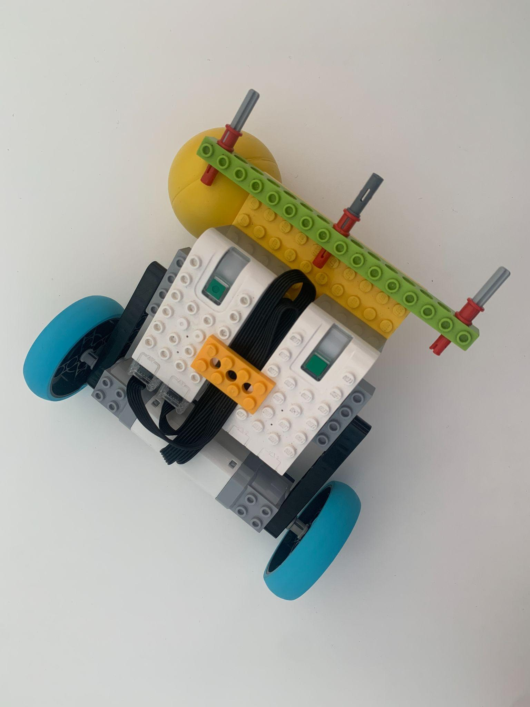

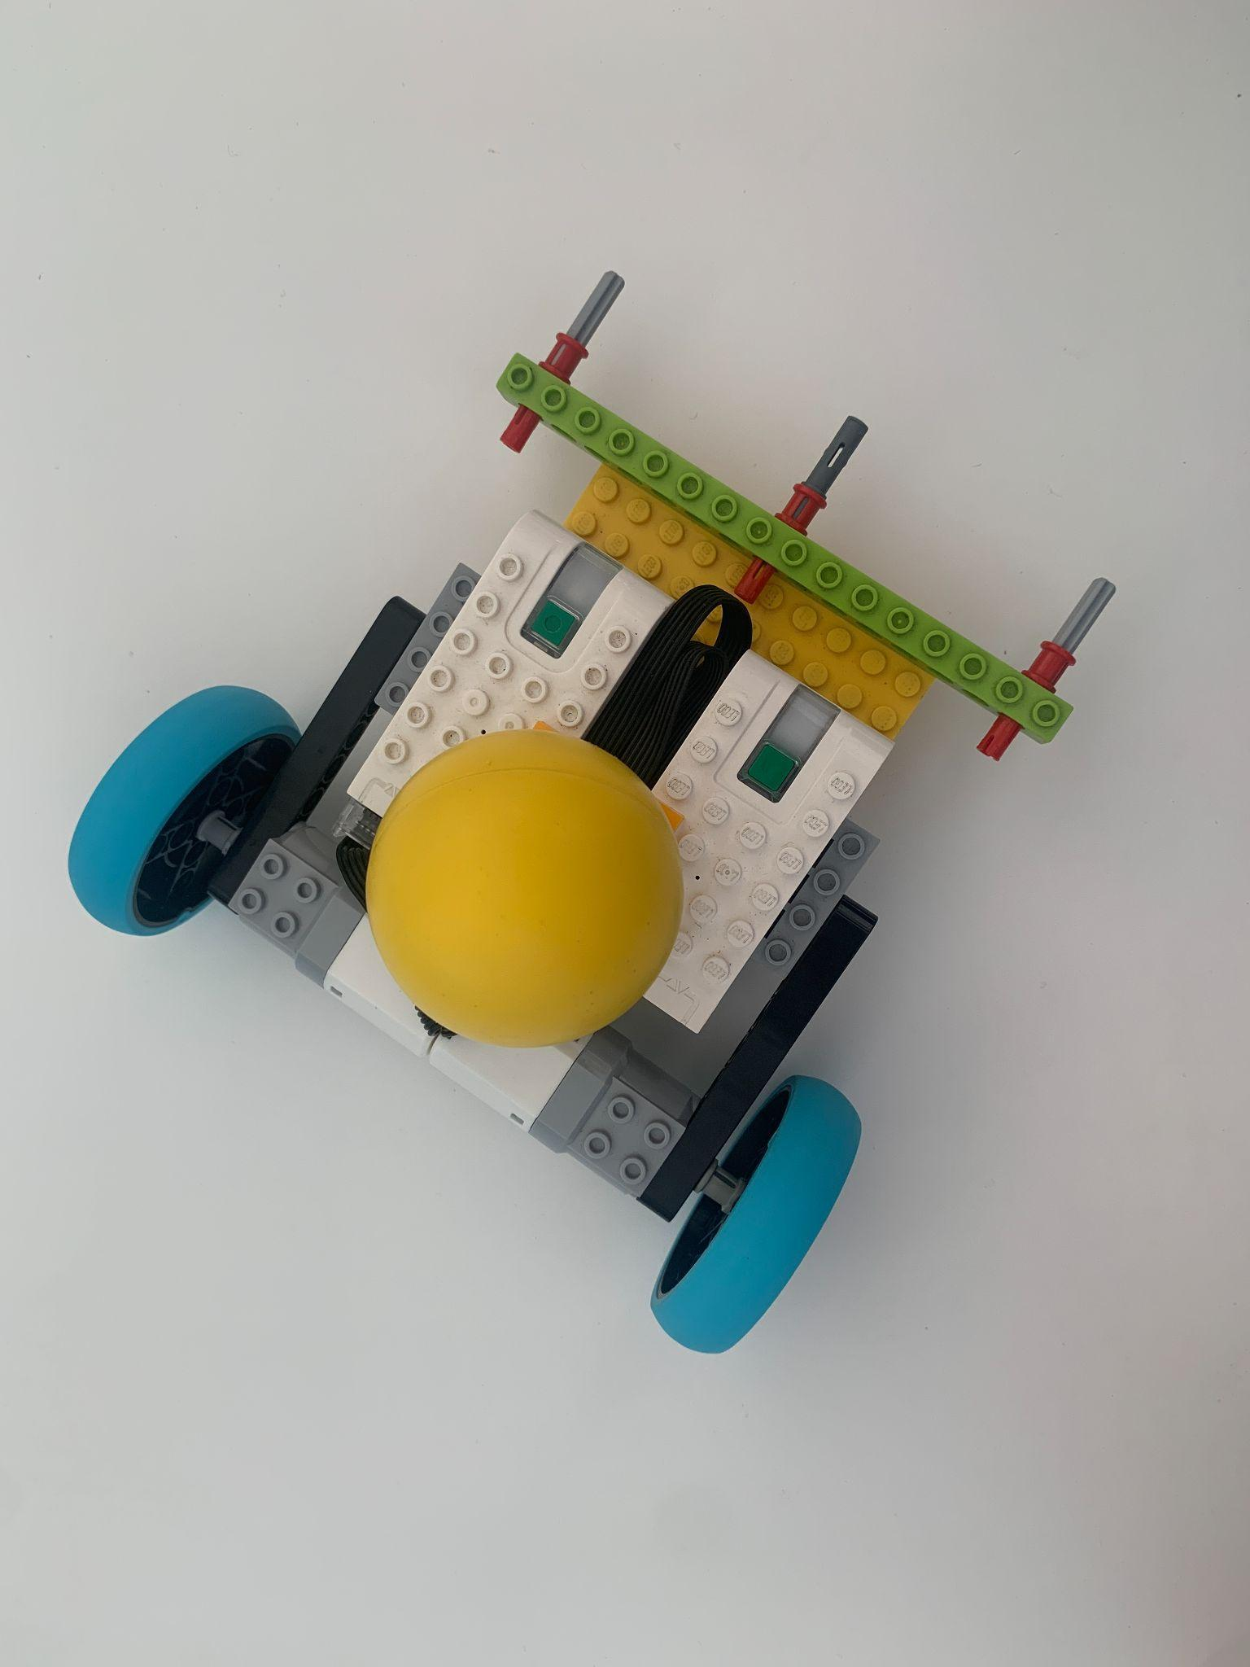

* + 1. Enter the goal for more than 5 seconds (see B.e)
    2. Excessively damage another robot, the field, goals, etc
    3. Break the USEF code of conduct
  1. If a team received three (3) penalty tokens by the conclusion of the match,their team will be disqualified from the rest of the match with a score of 0
  2. If a robot is disqualified two times throughout the elimination matches of the event, they will be disqualified from the rest of the event