Challenge Yourself, Invent the Future

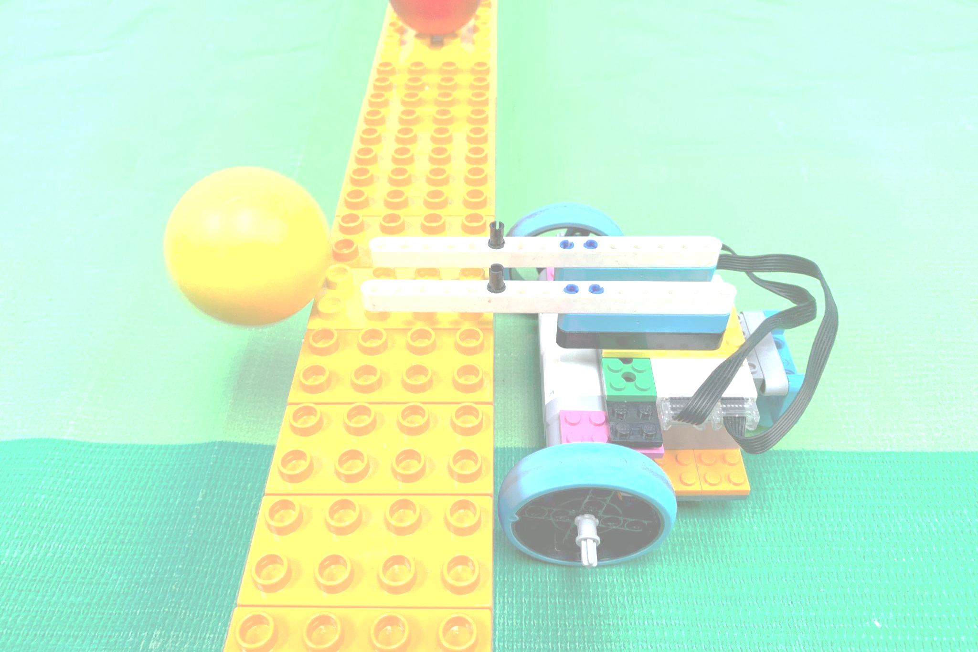

6-10yrs
BALL BLITZ
RULES

1. Overview
- Students will be facing off in a game to score more points than the opponents.
- Teams consist of one (1) to two (2) students
- Students must be no younger than six (6) and no older than ten (10) years old on the day of the competition
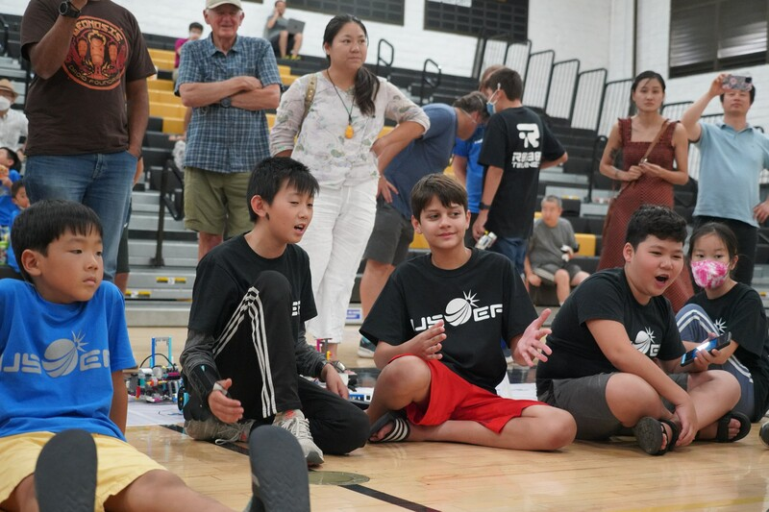
- There are two separate divisions that will compete independently of each other: a LEGO WeDo 2.0 division and a Spike Essentials division. Robotics systems including motors and sensors must be from each respective set, e.g., if you are using Spike Essentials, you cannot use any WeDo 2.0 motors or sensors. Divisions may be combined depending on enrolment
  - Division 1: WeDo 2.0
  - Division 2: Spike Essentials
- Coaches may work with multiple teams; however, it is recommended to have an assistant coach for each team
- Teams must build and code their robots independently. Coaches are not allowed to build or code and KIDS DO THE WORK.

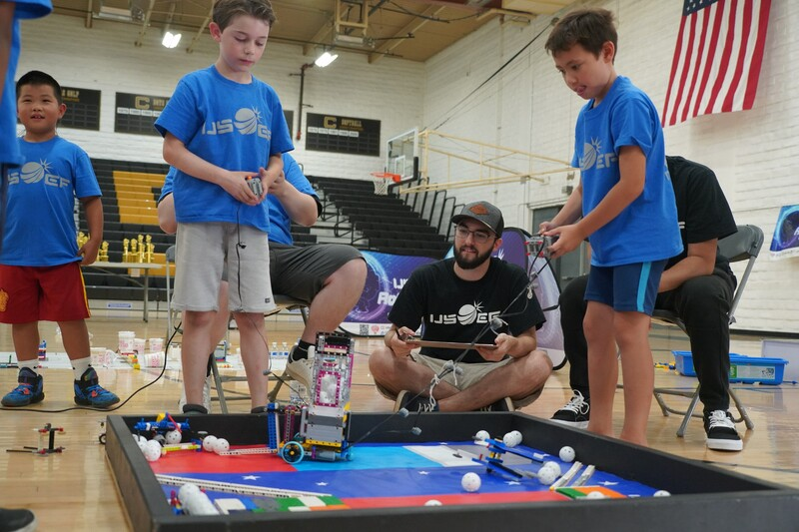
2. Equipment and Materials
- A maximum of two (2) LEGO WeDo 2.0 (45300) or Spike Essentials (45345-1) system’s may be used
- Students may use up to four (4) motors and any amount of sensors
- Any amount of LEGO pieces may be used to construct the robot
- LEGO and robotics systems may not be modified from their original shape
  - Any LEGO that appears modified will be checked at the head referee’s discretion
  - Robot parts cannot be permanently fixed with glue, screws, etc.
- Robots will require a way to control them;
  - Controllers can consist of up to two (2) of the following in any combination:
    - Laptop
    - Phone
    - Tablet
- Students may only code using Scratch, LEGO WeDo 2.0, or LEGO Spike Essentials
- Students are not allowed to adjust their code during a match

3. Robot Specifications
- Maximum weight: 1kg
- Maximum dimensions: Robot must fit into a 25cm cube
- Robots can be constructed in any way as long as they adhere to the Equipment and Materials section

4. Field
- The play field has an inside perimeter of 45 in x 95 in
- The perimeter of the play field has a wall measuring three (3) inches tall
- The mat is secured to a smooth surface in order to ensure that the surface is seamless
  - When securing the mat to the table, use gaffer tape, secured at all four corners, and the midpoints of all four sides.
- Play field details:
  - A divider in the middle separates sides A and B. The divider is made by building a 3 high, 4 stud wide DUPLO wall that spans the width of the table. The wall should be secured to the mat so it does not move when bumped
  - The white area at either end of the field is called Home
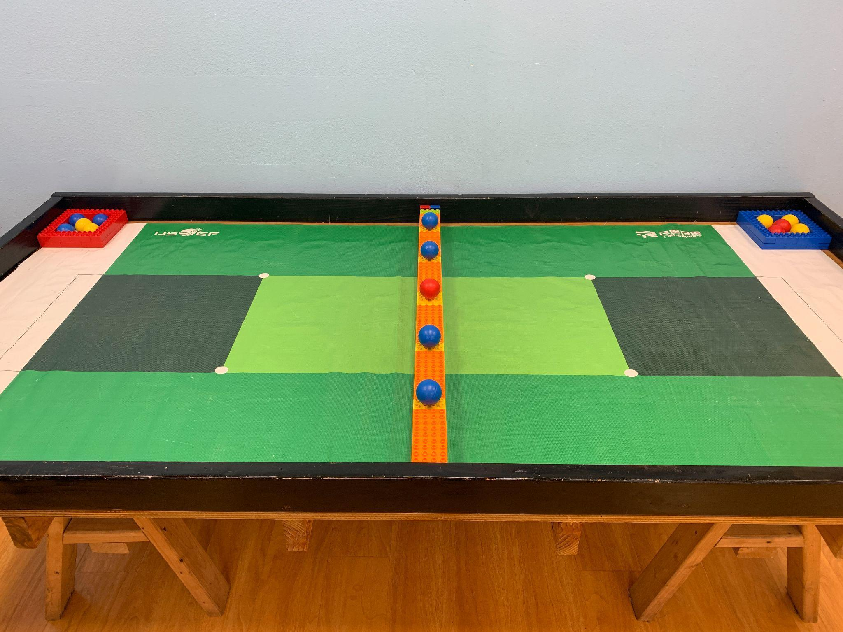

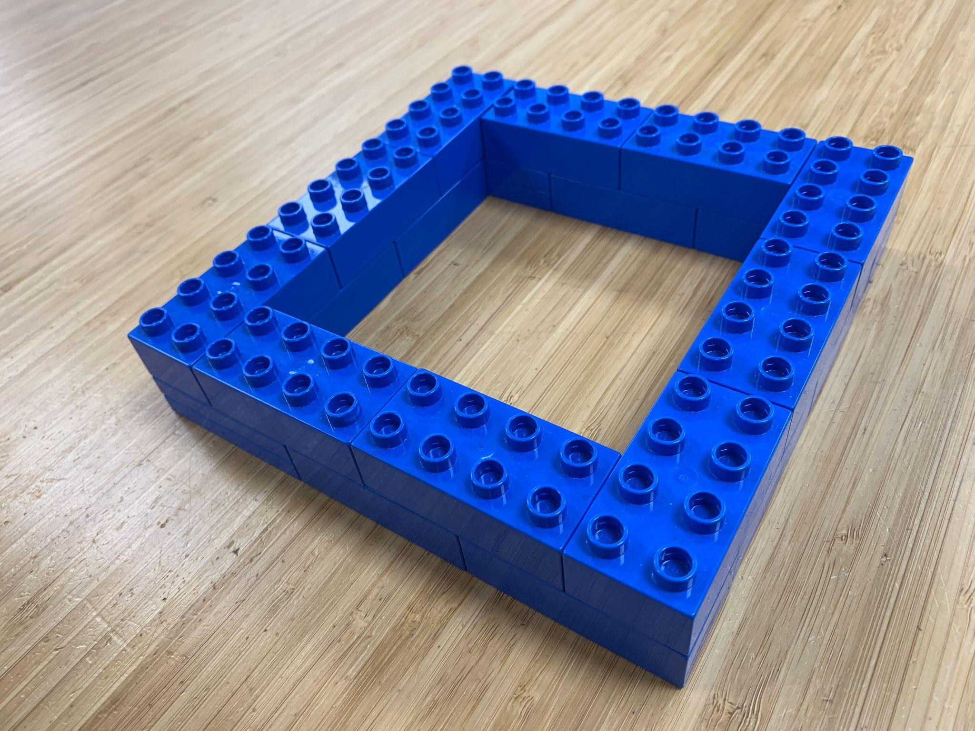

Field cont.
Fifteen (15) LEGO Duplo Ball (41250) will be used as scoring elements

Storage Boxes
There are 2 storage boxes, one red and one blue. They are placed at either side of the field

Items Needed:
20 Red 20 Blue (40) 3011

Field Divider
A divider is placed separating either side of the field. One side is blue and the other side is red. The field is 3 Duplo blocks high and and 4 studs wide. The top row is made up of orange and yellow blocks. The yellow blocks have 5 orange blocks in between them. The center yellow position has two yellow blocks. One edge uses lime green 2x2 brick with Pin on side with grove (22881). This allows for an extra brick to be placed on its side to fill the side gap. If the green block (22881) cannot be used, secure the additional vertical blocks to the wall using an adhesive. Secure the whole field divider to the center of the field using an adhesive such as gaffer tape.

Items Needed:
35 Blue, 35 Red, 28 Orange, 6 Yellow (94) 3011
2 Blue, 2 Red (4) 3437
2 green (2) 22881 (or an additional orange 2x4)
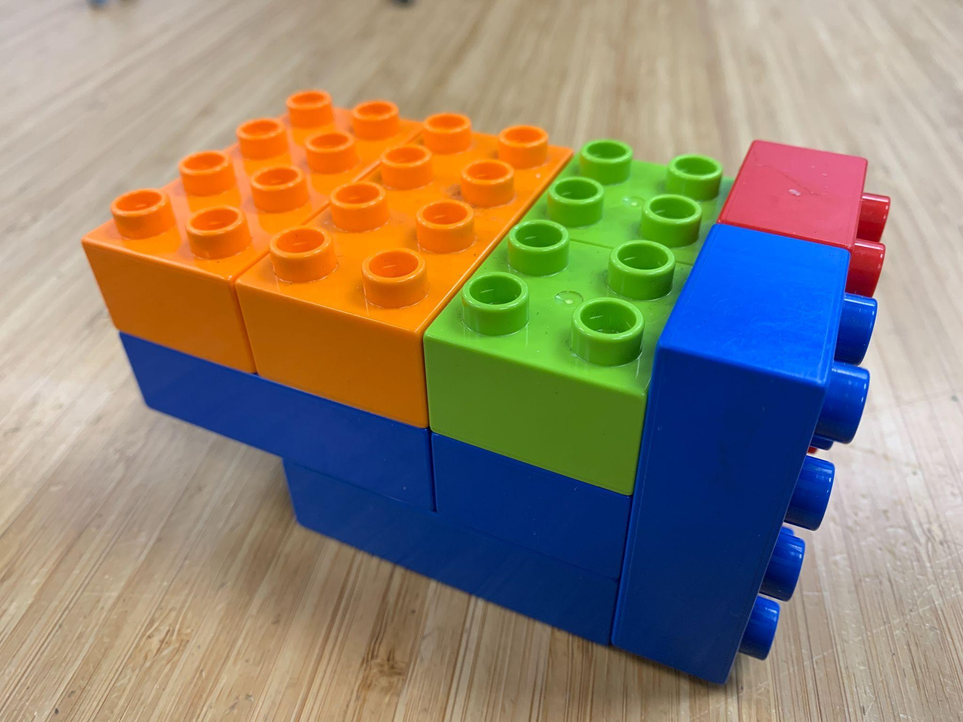
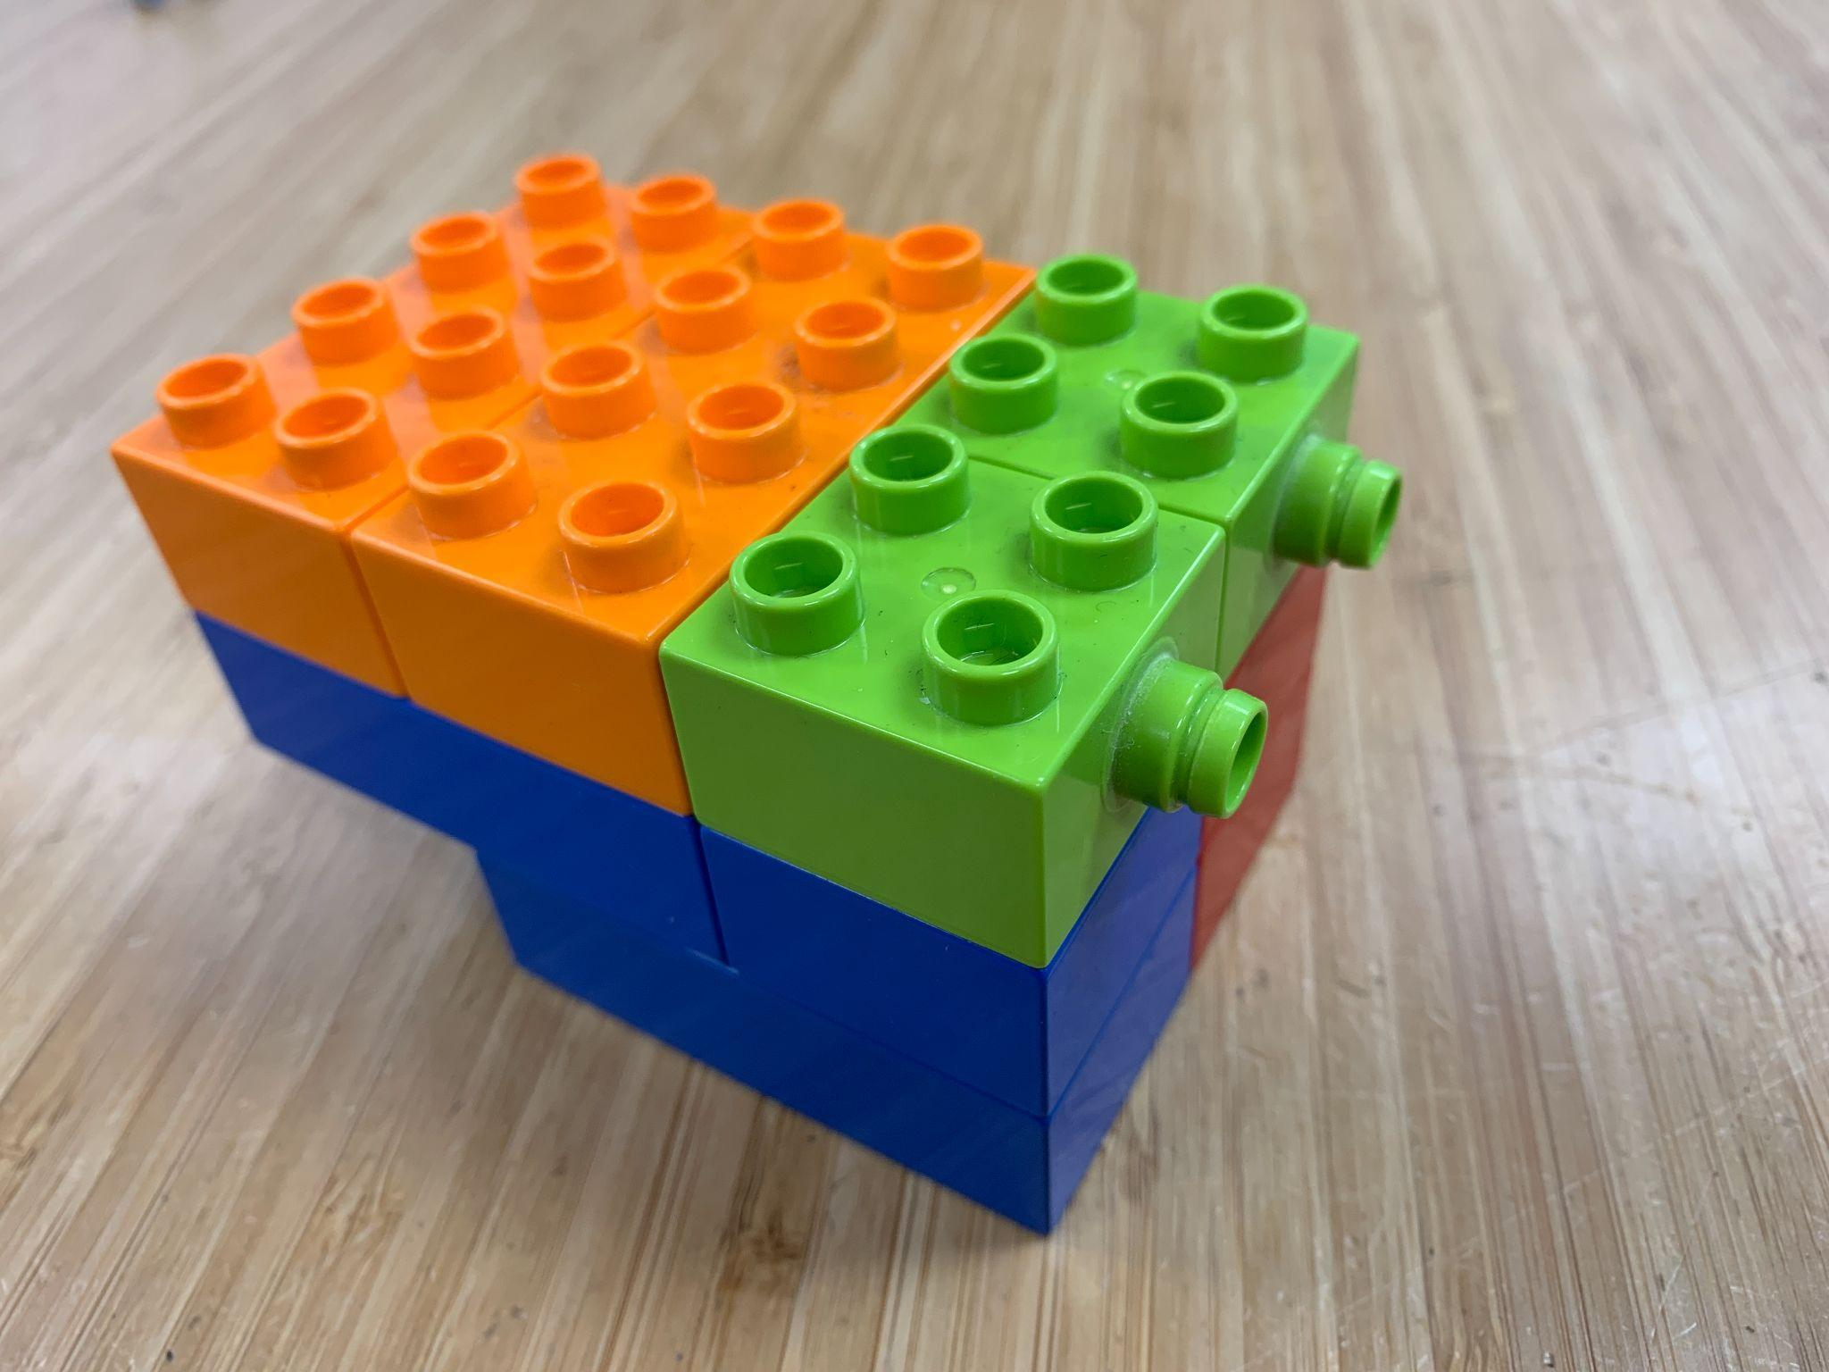

5. Preparing to Play
- Teams play in a 1 vs 1 or 2 vs 2 game of Ball Blitz
- Teams are randomly paired before the beginning of each match
- Preparing the field
  - A center divider is taped down to the center of the field
  - Two (2) storage boxes are used in a game, one (1) for the blue side and one (1) for the red side.
  - Ten (10) balls are placed in the storage areas. Five (5) in each storage area.
  - Five (5) balls are placed along the center divider on the yellow blocks in the center of the blocks.

6. Playing the Game
- Start of the match
  - Robots are placed completely in home, at any position
  - Robots may use one (1) of their Home Zone balls to preload onto their robot
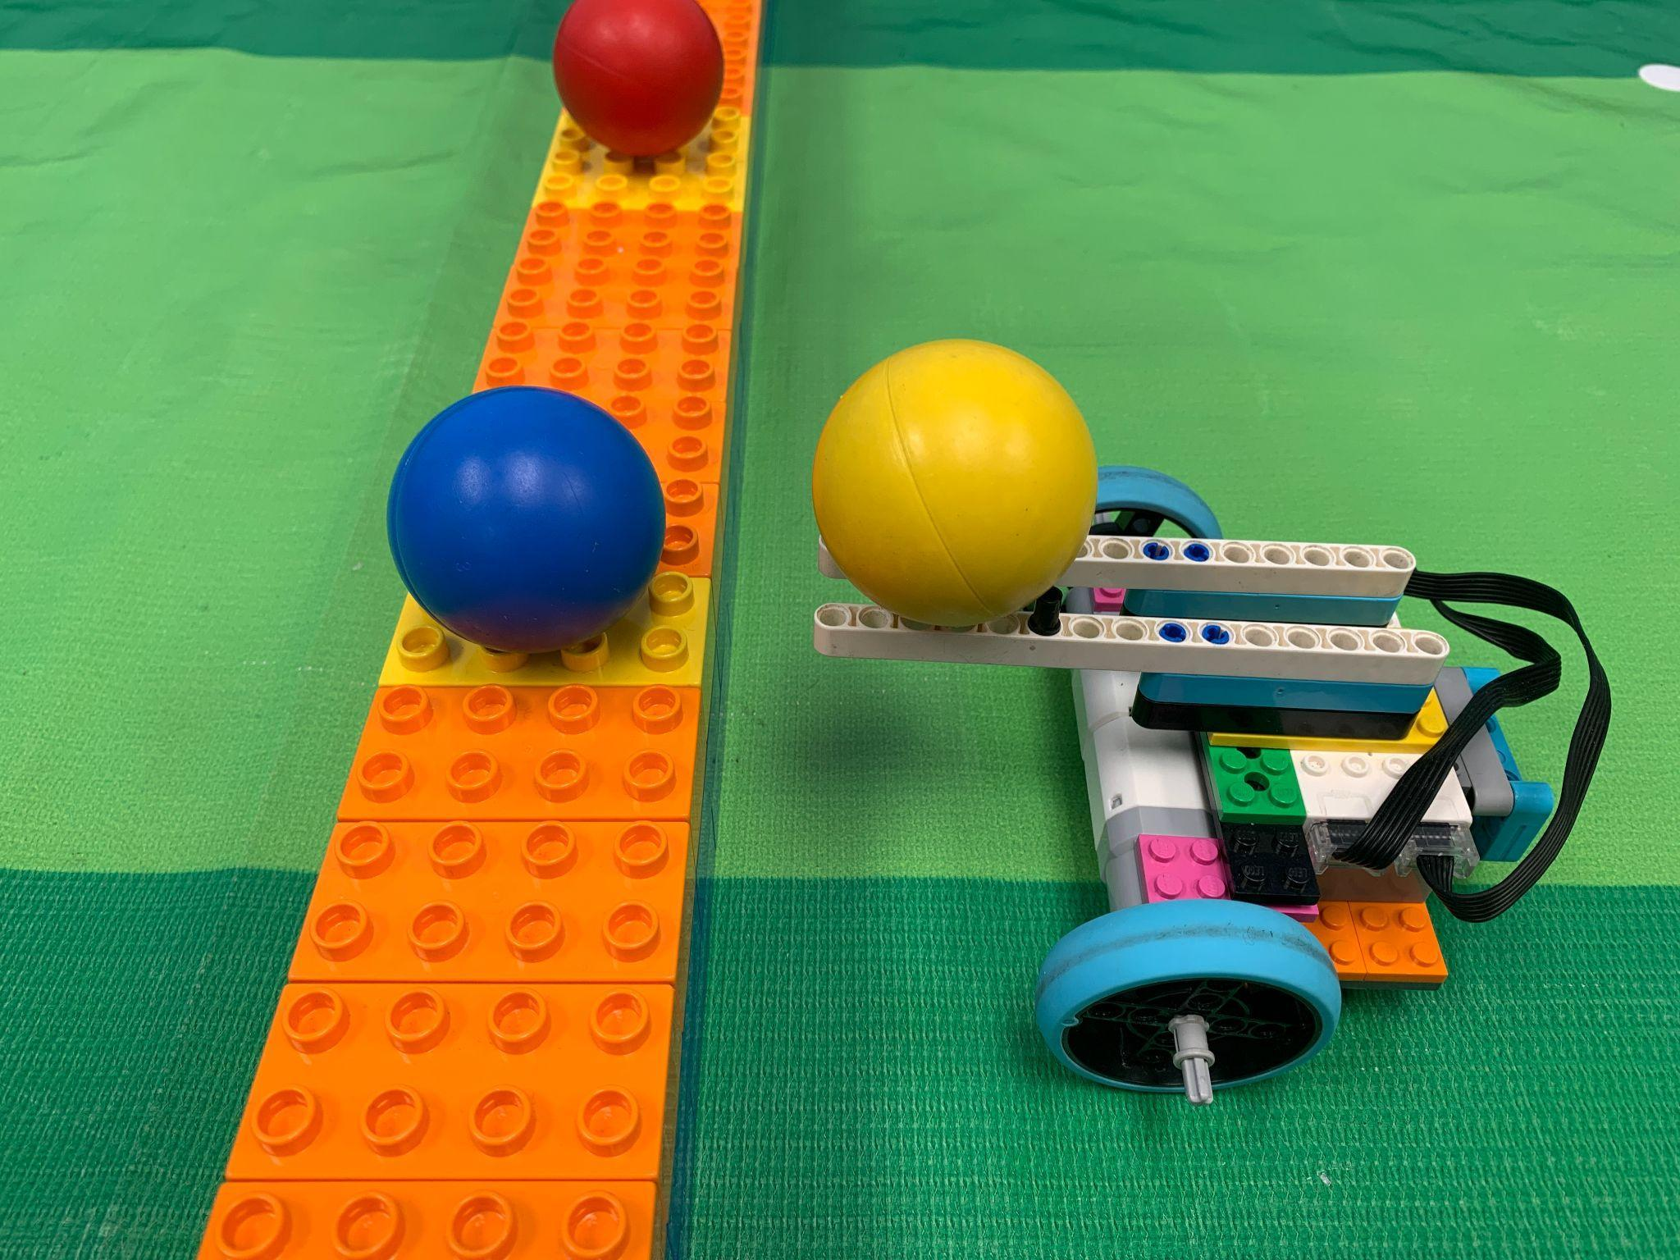
  - The referee will start the match.
- During Play
  - The goal of the game is to push balls over to the other side of the center divider and have the FEWEST amount of balls when the match is over. Each match lasts a maximum of 2 minutes and 30 seconds.
  - Robots can only be touched if any part of the robot is touching the Home Zone.
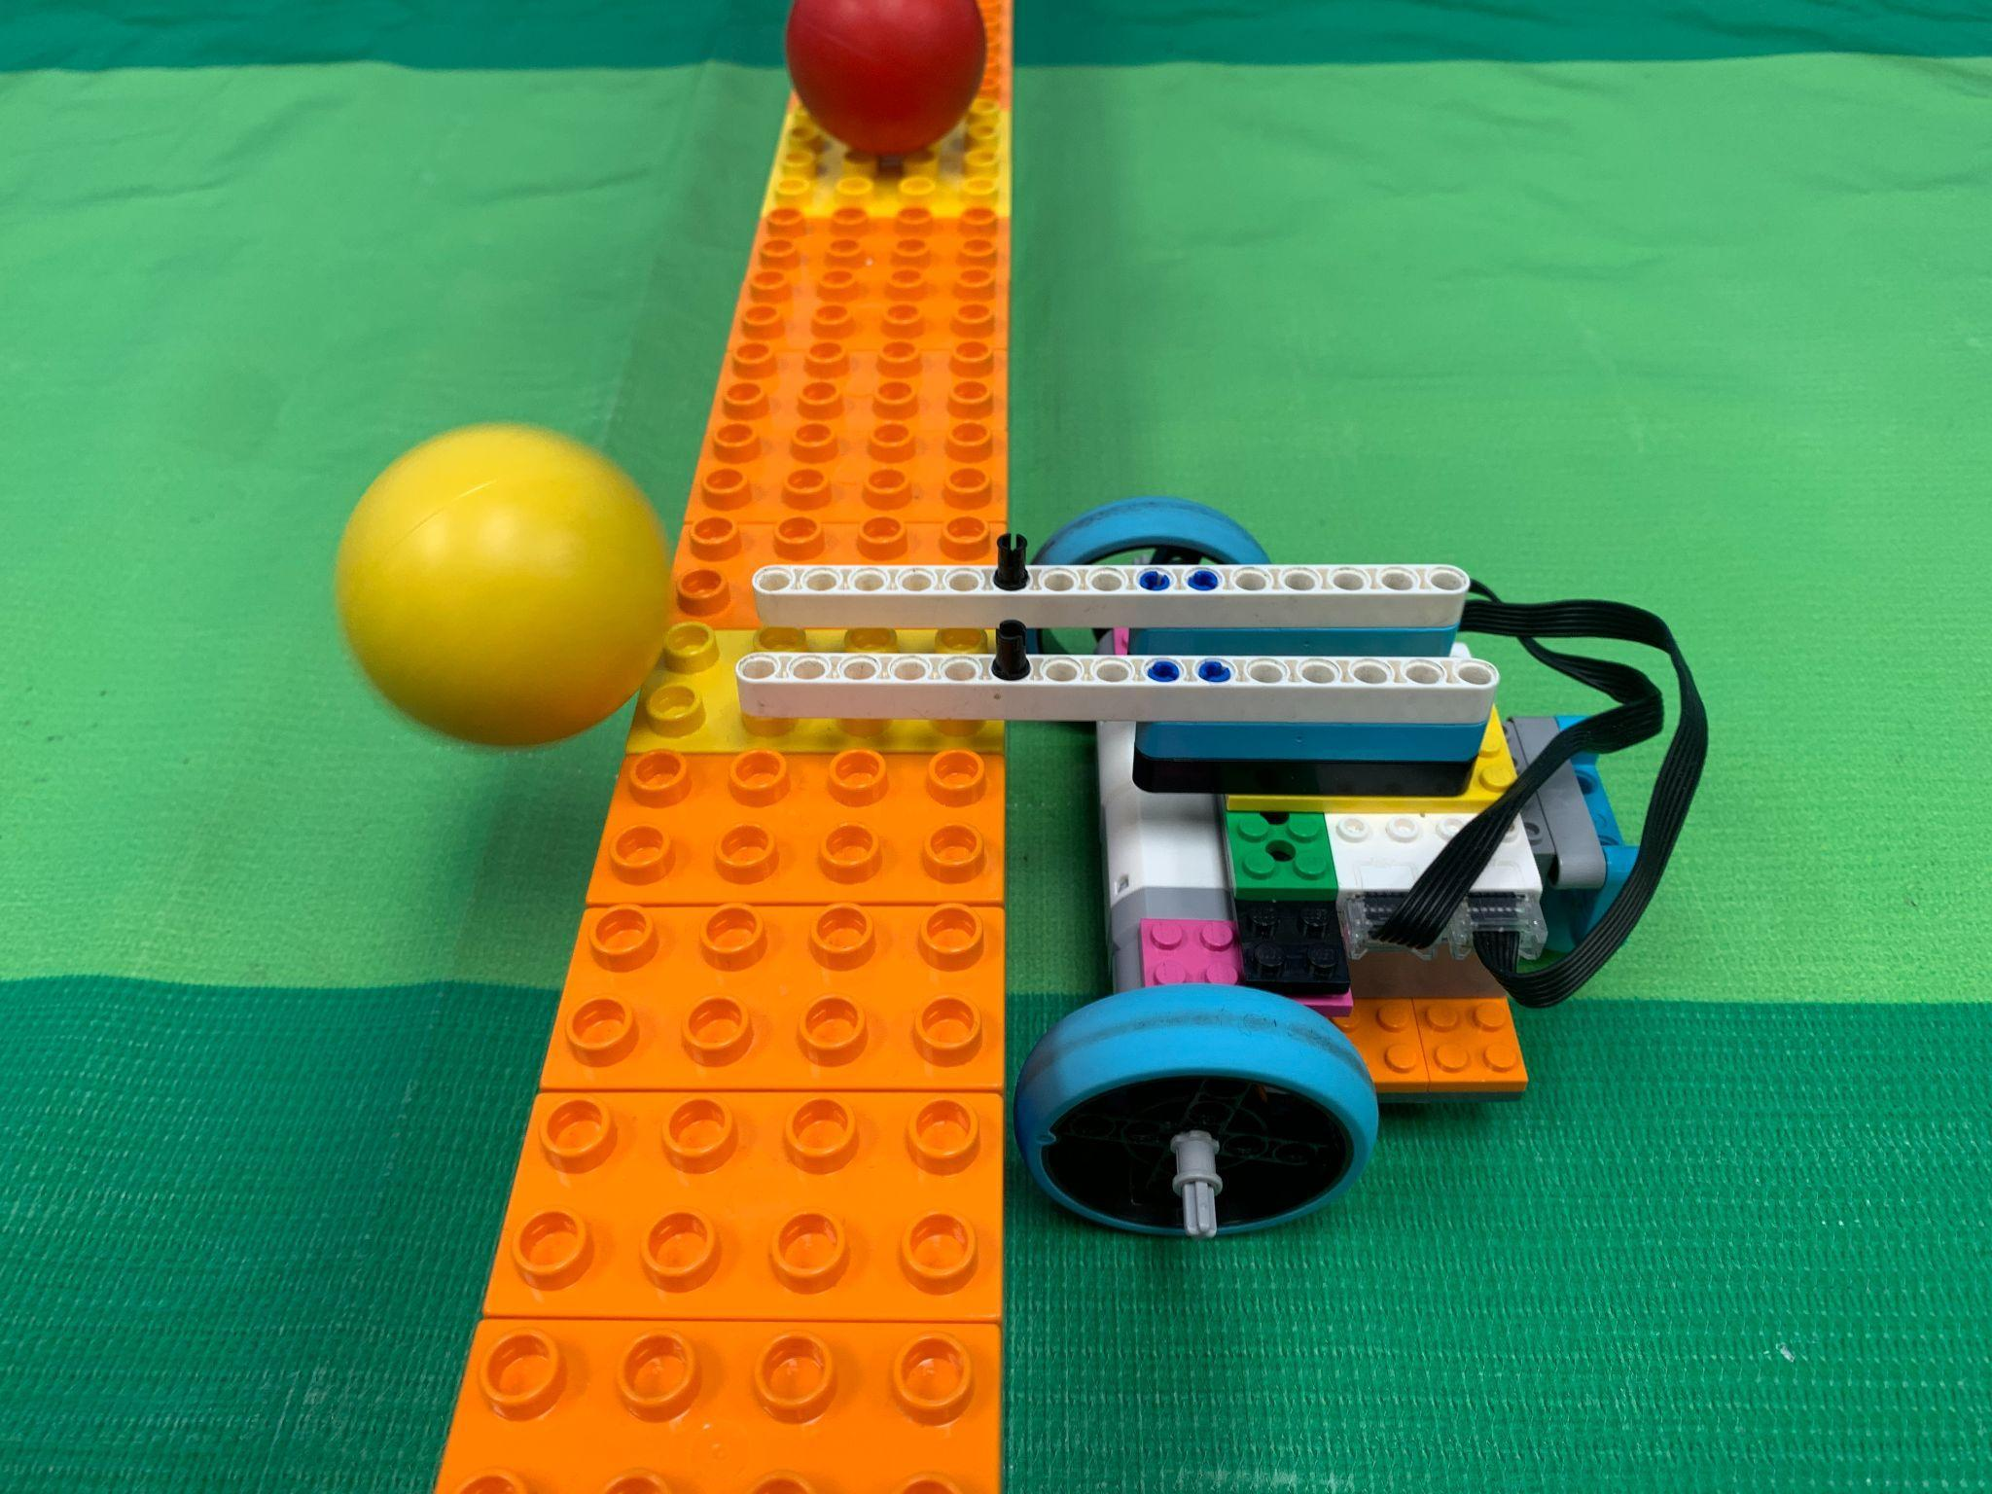
  - If a robot is in home, the human player can load a ball that is in their home onto their robot
  - A robot can only control one (1) ball at a time
  - A robot can push a bonus ball over to the opponent's side, even if they are carrying a ball
  - A robot can move a ball on their side to bring it back to their Home Zone
  - Balls may not be launched from their Home Zone and score on the other side
  - If a ball goes out of bounds, it will be returned to the storage box of the robot who touched it last

- Resolving a Tie
  - If a tie occurs a head to head match is initiated.
  - Robots are placed in their home
  - Only one ball is used and placed in the center position on the center divider
  - When the ref completes saying “READY, GO!” both robots quickly attempt to push the ball to the other side
  - If the ball touches the floor of the other side, the robots with the least amount of balls is the winner
- Penalties
  - If a penalty is given to a team their robot is returned back to their Home Zone
  - Minor Penalties: The robot is returned to home and then a 5 second countdown is started. While the countdown is on, the robot may not move.
    - The robot is touched by the human player if it is completely outside of the Home Zone
    - The human player touches a ball outside of the Home Zone
  - Major Penalties:The robot is returned to home and then a 10 second countdown is started. While the countdown is on, the robot may not move.
    - The robot touches the other side of the center divider
    - The robot scores multiple balls at the same time
    - The robot launches a ball from their Home Zone
  - Disqualification
    - If a team acquires more than one (1) major penalties they are disqualified from the match

