Challenge Yourself, Invent the Future

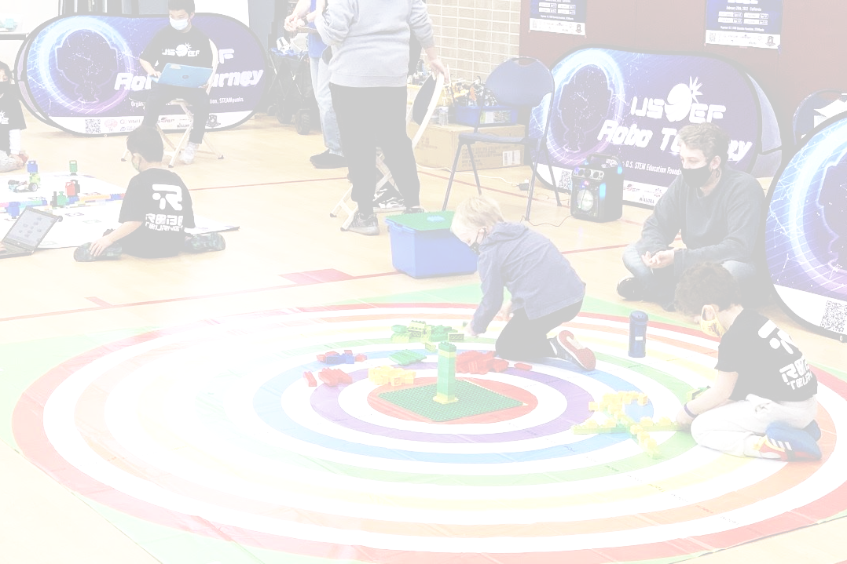

yrs3-6yrs

INFINITE

EXPANSION

RULES

1. Overview
- In Infinite Expansion, teams of children aged three (3) to six (6) will use LEGO Duplo pieces in order to construct a tree with eight branches. The tree will be scored based on the length of its branches
- Each team consists of two (2) children and one (1) adult coach
- Team members must be no older than six (6) on the day of the competition
- Team members are only allowed to compete in one (1) team at the event
- Coaches may work with multiple teams. It is recommended that if a coach has multiple teams, they have assistance for each team such as an assistant coach or parent volunteer

2. Required Materials
- A set amount of 144 pieces will be used to construct the tree (excluding the two aforementioned beginning pieces). These pieces are as follows:
  - One (1) Duplo Building Plate (10980)
  - One (1) 4x4 LEGO Duplo plate (14721)
  - Forty (40) 2x2 LEGO Duplo Squares (3437)
  - Sixty (60) 2x4 LEGO Duplo Rectangles (3011)
  - Four (4) 2x8 LEGO Duplo Rectangles (4199)
  - Thirty (30) 2x4 LEGO Duplo Plates (40666)
  - Four (4) 2x8 LEGO Duplo Plates (44524)
  - Eight (8) 2x3 LEGO Duplo Curved Slopes (2302)

 | 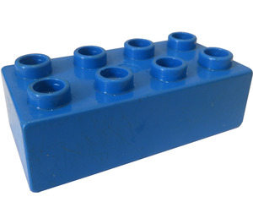 | 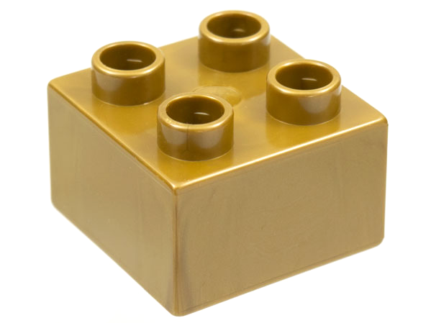
4 - 2x8 Rectangles (4199) | 60 - 2x4 Rectangles (3011) | 40 - 2x2 Squares (3437)
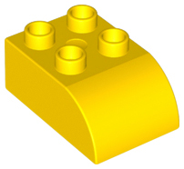 |  | 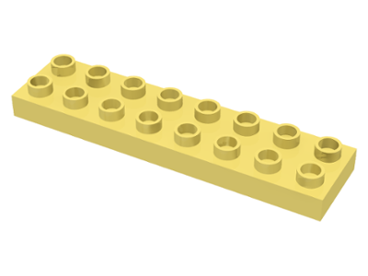
8 - 2x3 Curved Slopes (2302) | 30 - 2x4 Plates (40666) | 4 - 2x8 Plates (44524)
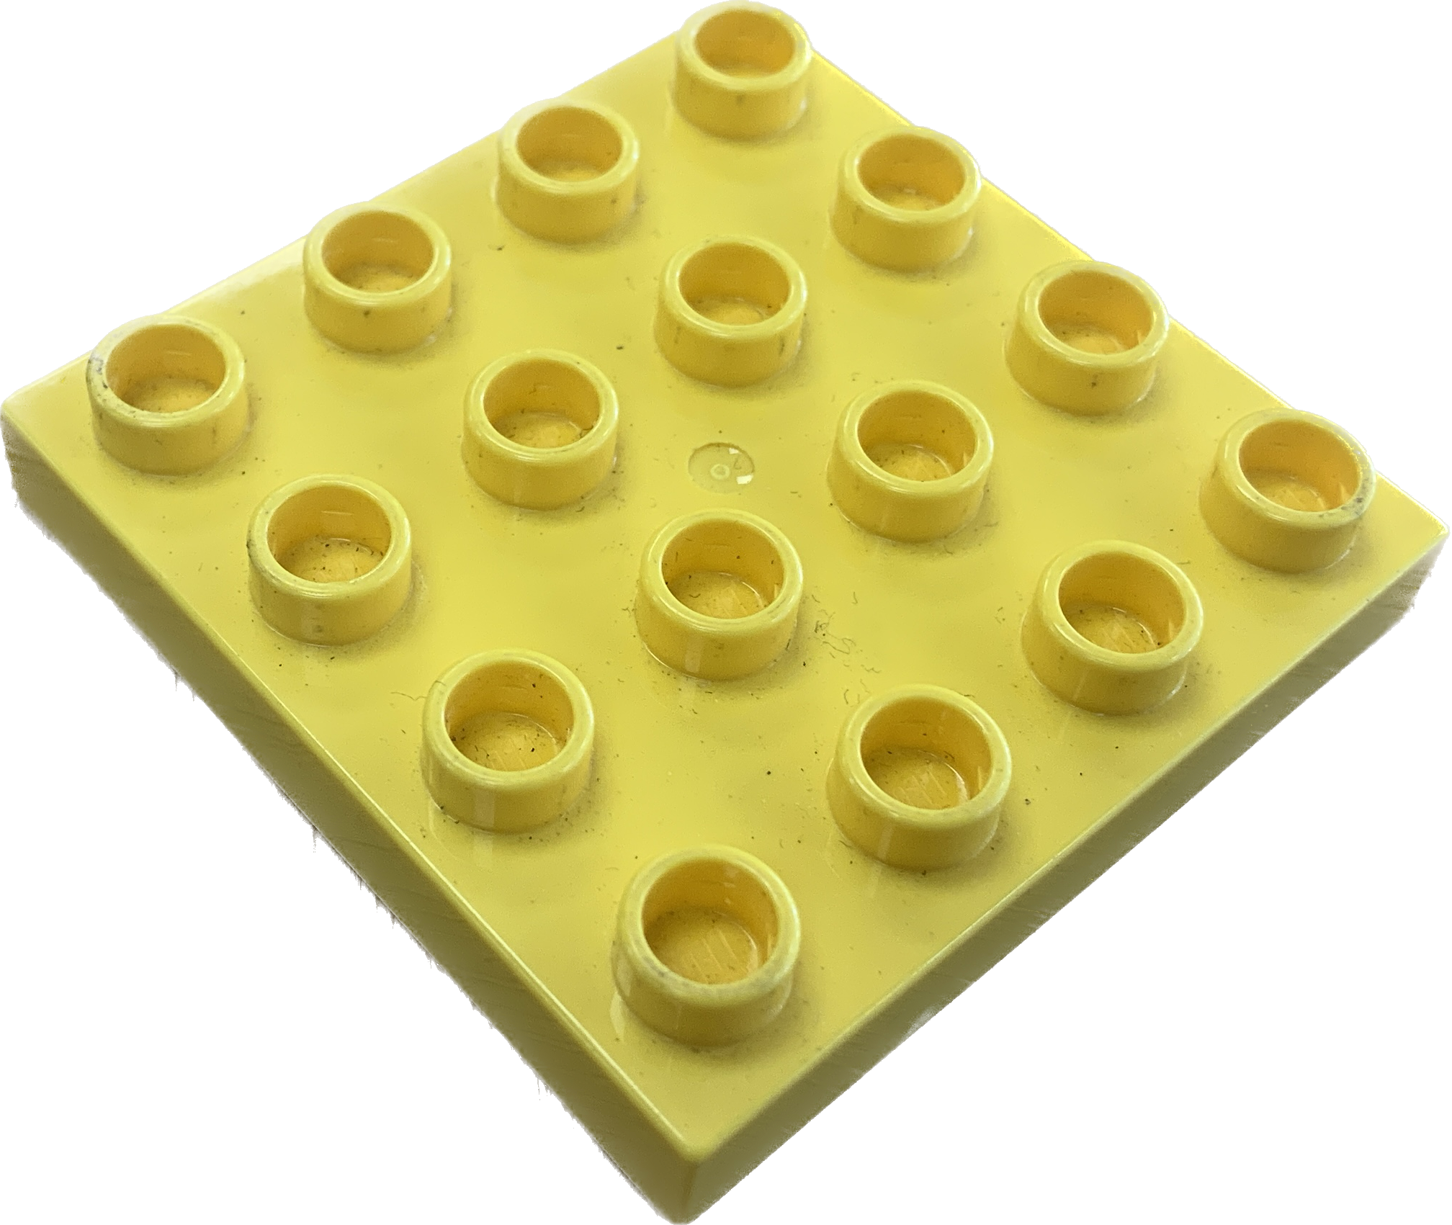
1 - 4x4 Plate (14721) | 1 - Building Plate (10980)

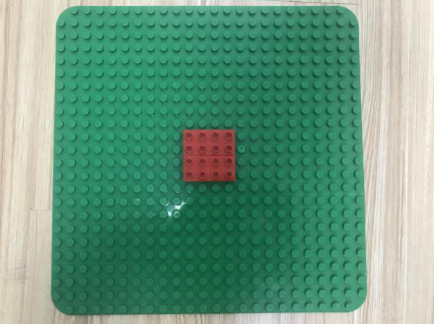
3. Competition Setup
- The competition field is 300x300cm
- Students will place their LEGO Duplo Building Plate on the yellow square in the center of the mat. The 4x4 plate is places in the center of the Building Plate
- Each ring on the mat is used to measure the length of each branch. Each ring has a thickness of 10cm.

4. Competition Task
- Teams of two (2) members and one (1) adult coach will have 5 minutes to construct a tree that will be scored based on the length of its branches
- Students will have a total of five (5) minutes to build their tree. Once the timer is up, students must no longer interact with their tree. If a team ends before the timer ends, students must raise their hand to demonstrate to a referee that a team has completed their tree.
- Students will build a tree trunk out of LEGO Duplo blocks above their 4x4 duplo plate. The structure must be a minimum of ten (10) blocks high. The tower must be either 2x4 or 4x4
- The tree must consist of eight (8) branches that reach out from the top of the tree trunk. Each branch will expand out towards North, Northeast, East, Southeast, South, Southwest, West and Northwest. The number on the bottom left of the map is in the Southwest direction.
- Branches cannot be parallel for more than eight (8) LEGO studs
- Each branch must be suspended above the ground and will not be scored if it is touching anything including the ground, participant, etc.

5. Scoring Criteria
- The distance of each branch will be added together in order to determine a team’s final score.
- Distance of each branch is determined by the judge observing how far the branch extends. When scoring, the judge will look from above the edge of each branch to see what circle they extended to. Scoring criteria is printed on the mat.
- If two teams have the same final score, the team that took less time to build during that score will be ranked higher
- Each team will compete for three (3) rounds. The lowest scores will be dropped when determining final placement

6. Penalty
- The following behaviors will result in a penalty:
- Connecting two adjacent tree branches
- Malicious damage to an opposing team’s build
- Violating the USEF code of conduct
- Penalties will be given out and punished based on the head referees discretion

